An Exploration of
Kriegsbriefe gefallener Studenten
And Editor Philipp Witkop

Zachary Norlyn
Hist 133c Prof. H. Marcuse
UCSB 2019

Zachary Norlyn is a History Major attending the University of California at Santa Barbara.

Abstract: In the First World War, Germany called upon its citizens to take up arms and fight for their country, the Father Land. While many representations of the German army that emerged in and after World War I showed them as hardened barbarians and savages; Philip Witkop’s compilation of letters serves to humanize these soldiers, giving us insights into the young men behind the uniforms. These letters, written by young students on the battlefront, give a unique glimpse into these men, their lives, and their beliefs—most notably their belief in their country. Over the decades, Witkop’s work has been cited and republished with different motives, yet each edition worked to keep these students’ memories alive in the hearts and minds of readers. The collection can serve to remind us that our enemies, no matter how different, have a story to tell, and a life, which might not be so different from our own.

I. ANALYSIS
War Letters of Fallen Students (Kriegsbriefe gefallener Studenten) is compilation of wartime letters penned by young students who enlisted in the German army in World War I. The collection showcases the first hand accounts of young men from various places in Germany, who wrote to family and loved ones at different times during the war, expressing different wants, perspectives, and experiences, yet all met the same unfortunate and untimely end in combat, or died soon after from their injuries. The book provides an unparalleled illustration of the mindset of young German soldiers and their sense of the German nation during World War I, allowing outsiders to experience the accounts of these young mens’ shifting sense of fate, nationalism, and war.
Dr. Philipp Witkop, the editor of German Students’ War Letters, was a German writer and literary critic. Born in 1880 in Freiberg, Germany, Witkop died near Lievin, Germany, in 1942, being remembered most notably for his contributions to wartime literature through his collection and publication of “what was at the time the best-known and most popular collection of wartime letters as a historical source.” The text remained a popular text through the Second World War, and was expanded from the original collection to include a larger archive in the second and third editions (1916, 1918, and 1928 respectively). While the first two editions were largely overlooked within Germany, the first edition was translated into English intended for a wider audience, namely the enemies of the German state. After another expansion to the collection, the third edition proved to be a bestseller, and was considered “as illustration and evidence of the purported purity of the young volunteers in numerous speeches held at university memorials commemorating former students.” The expanded volume in 1928, supported by the Ministry of Education and several German universities that had contributed additional letters, supported this effort to memorialize the war through first-hand accounts.
The third edition’s warmer reception within Germany invited more attention from literary critics, spurring reflections on Witkop’s editorial style, as well as musings about the collection’s larger contribution to German history. A 1930 review by Felix A. Witmer suggests that despite the expansion the volume could have provided some clearer logic behind its organization, however Witkop “has chosen and abridged the material as a fine connoisseur of depth and of human values.” Witmer concludes that while much will be forgotten about the war in time, Witkop’s collection helped memorialize these men, and this moment, for future generations.
By 1929 the collection was viewed as a significant contribution to the arena of war literature, “understood as a genre of writing in which soldiers display the authority of direct experience in telling their “truth” about war and combat,” wrote Jay Winter in his 2002 introduction. Winters suggests that beyond their own musings, the writers in their personal letters “offer reflections on much else besides—on comradeship and masculinity, on the image of the enemy, on national sentiment, on the burden of survival when so many others failed to come back, and on the “lies” that those who weren’t there told about those who were.” Such insights speak to a larger aim of Witkop’s own work, a drive that prevailed in many of his projects, including, Recent German Lyric al Poetry (Die neuere deutsche Lyric) in 1910, Women in the Life of German Poets (Frauen im Leben deutscher Dichter) and German Life of the Present (Deutsches Leben der Gegenwart) both in 1922.
Witkop’s body of work follows a common theme. One that is, “determined by the constant search for ways out… [His works] are all about the search for happiness and the union with the allies, which ultimately fail.” In his forward that was reprinted and translated, with Witkop himself as an editor, Witkop discussed his hopes for what the book would mean to readers. As translated by A.F. Wedd, “Professor Witkop expresses the hope that the letters may form a living memorial…as an example of devotion to duty, of self-sacrifice and patriotism…[and] help towards the establishment of justice and a better understanding between nations.” Witkop understood the emotional magnitude of the collection as a heavy yet important weight on readers, helping to remind us how similar we are, even when on opposite sides of a battlefield.
6 Wedd, A.F. “Introduction: Witkop, Philipp. German Students' War Letters. Translated by A. F. Wedd. New York, NY: E.P. Dutton and, 1929. Printed in England

II. ANNOTATED BIBLIOGRAPHY
Witkop, Philipp. Kriegsbriefe Gefallener Studenten. Teubner: Leipzig, 1916, 1918, 1928.
- No reviews found on this specific version of Kriegsbriefe Gefallener Studenten

Wittmer, Felix A. Books Abroad 4, no. 1 (1930): 79. doi:10.2307/40046716
  - Kriegsbriefe Gefallener Studenten. Edited by Professor Dr. Philipp Witkop. Munchen George Muller. 1929- “In 1918 Professor Witkop could publish only a very small volume of War Letters of German Students (Teubner), but he can now present a larger selection. The Ministry of Education as well as the German universities placed at his disposal about 20,000 letters. The editor should perhaps have given a more inward and psychically more obvious order than the chronological, but, on the other hand, he has chosen and abridged the material as a fine connoisseur of depth and of human values. Many facts of the war already are and will be forgotten, but here remains a document of the soul of a great people.” – Felix A. Wittner. Washington and Jefferson College.

Witkop, Philipp. Kriegsbriefe Gefallener Studenten. München: Langen/Müller, 1939.
No reviews found on this specific version of Kriegsbriefe Gefallener Studenten

Witkop, Philipp. Kriegsbriefe Gefallener Studenten in Verb. Mit D. Dt. Unterrichts-Ministerien Hrsg. München: Albert Langen, 1942.
No reviews found on this specific version of Kriegsbriefe Gefallener Studenten

Höfele, Karl Heinrich. "Epochengefühl und Wandlungsbewusstsein im Ersten Weltkrieg." Zeitschrift für Religions- und Geistesgeschichte 10, no. 2 (1958): 142-58. http://www.jstor.org/stable/23896250.
  - Karl Heinrich Höfele, a German author, cited Wilkop’s work in his writing of ,,Epochengefühl Und Wandlungsbewusstsein Im Ersten Weltkrieg." Zeitschrift Für Religions- Und Geistesgeschichte. (Translated, “Epoch Feeling And Action Awareness In The First World War. "Journal For Religious And Intellectual History”) Höfele used Witkop’s work to underline the point of martyrdom in the war. Many of the students in Witkop’s collection had strong views of faith, and many saw death as potential martyrdom while fighting against their enemy, and the contradictions of such mentality while still holding faith.
    - Translated quote: “…faith spread among the people; In the victory of one's own troops, one saw the obvious sign of the help of God; he apparently used the Germans as the executor of his will to chastise the enemy, who after all conjured the war with a murder. The question could seriously be raised as to whether the fallen should not be martyred in the ecclesiastical sense.” –Höfele

Jarka, Horst. "Soldatenbriefe des ersten Weltkrieges und nationale Bildungsideologie." Monatshefte (1975): 157-166.
  - Horst Jarka, a German author of wartime history, cited Witkop’s work in this article. The title translates as, "Soldiers' Letters of the First World War and National Educational Ideology." Jarka discusses the effect of the educational policies in Wilhelmine Germany leading up to the First World War, and how they focused on nationalistic ideologies. He states that the language in Witkop’s collection echoes and accepts national propaganda and blind patriotism without question. Jarka argues that these letters help continue this blind view of nationalism to future generations of its readers by showing the fervor in the writings of these fallen students, increasing the allure of patriotic martyrdom.
  - A translated excerpt from this article: “Ten years after the debacle of 1918, the time has come again to stir the drum, at first to a hero's memory. In 1928 the same German man presents a more extensive collection of field post letters; but this volume, bound in earthy brown coarse linen with a blood-red title in Gothic script, contains only letters from fallen students. In the introduction, there is no lack of national pathos, but Witkop tries - in a somewhat paradoxical way - to portray the legacy of the fallen as an appeal for popular understanding. Already five years later, in the fall of 1933, there will be a new edition at Langen-Müller. The foreword adapts to the new conditions: the pacifist gesture of 1928 has been abandoned, Witkop returns - almost relieved - to the uniquely national tone of his 1916 foreword.”

Dietrich, Donald J. "National renewal, anti-Semitism, and political continuity: A psychological assessment." Political Psychology (1988): 385-411.
  - Donald J. Dietrich, (1941-2013), was the chair and professor of Boston College's department of Theology. Dietrich cites Witkop’s collection when examining the suggestions that these German students’ experiences of economic and social chaos in WWI showed how they were attracted more by the allure of national renewal and anti Marxism, rather than antisemitism and Nazism as was made prominent under Hitler.

Eksteins, Modris. Rites of spring: The Great War and the birth of the modern age. Houghton Mifflin Harcourt, 2000
  - Modris Eksteins, (1943- ) is Latvian historian of Canadian and German history. He explores the beginnings of World War I and the impact that the aftermath had, eventually leading the rise of Hitler and World War II. In his book, Ekstein cites Witkop’s collection by while examining Witkop’s intentions for choosing such poignant passages to be published in his 1916 edition Kriegsbriefe gefallener Studenten. Eksteins’ writings suggest a tone of admiration for Witkop’s collection, rather than a critical interpretation.

Winter, Jay. "FOREWORD: Philipp Witkop and the German “Soldiers’ Tale”." In German Students' War Letters, edited by Witkop Philipp, by Wedd A. F., V-Xxiv. University of Pennsylvania Press, 2002. http://www.jstor.org/stable/j.ctt3fj1v1.2.
  - An unnamed contributor of the University of Pennsylvania Press noted their take on Witkop’s book. They discuss how this book helps to feed the need of curious wartime literature enthusiasts. This book helps enable those who enjoy this genre the truths of those who fought and died for their country, while showing them for the people that they are, instead of the enemy they are commonly portrayed as. While this book indeed explores the truths of war, it also serves to expose the lies about these battles by people who were never there in the first place.

Weinrich, Arndt. "Kult Der Jugend — Kult Des Opfers. Der Langemarck-Mythos in Der Zwischenkriegszeit." Historical Social Research / Historische Sozialforschung 34, no. 4 (130) (2009): 319-30. http://www.jstor.org/stable/20762415.
- Dr. Arndt Weinrich, a German historian and author, cites Witkop’s collection as an example of the “myth of sacrifice” which was carried out by the cult culture of German youth during the interwar period in Germany. He references Witkop’s collection by how the fallen students sorties stories would later be interpreted by a new generation of German youths who grew a fervor for an attempt to come to terms with not only the loss of the German army, but the unprecedented amount of deaths that were seen to be for naught. Furthermore, he examines the evolution of male solders masculinity, and how the fallen students wartime letters affected it.

Witkop, Philipp. Kriegsbriefe Gefallener Studenten. Berlin: Epubli, 2018.
Iron Cross on red cover. Edited by Philipp Schröder
- Philipp Schröder rereleased and edited the latest edition of Kriegsbriefe Gefallener Studenten in 2018. Very few details about Schröder are available, other than his edition of Witkop’s collection was published in its native German, as well as the re-release was depicted with a bold red cover with an Iron Cross. He has also re-published Immanuel Kant’s Von den Verschiedenen Rassen der Menschen, also in 2018. When releasing the latest edition of Kriegsbriefe Gefallener Studenten, he chose to use a quote by the Austrian playwright and poet, Erwin Guido Kolbenheyer (1878-1962), to describe his take on Witkop’s collection.
- "I can not remember a book that would have shaken me more deeply than this collection of war letters of fallen students. There will be few books of world literature that would be more uplifting. Pure feeling, most intimate experience in every line and a language of rare nobility! Not a phrase, nothing of national kitsch, but heroism of a nation. Whoever thinks that our people have been beaten and overcome, hear these dead. "- Erwin Guido Kolbenheyer

III. NGRAM RESULTS
The Ngrams follow a similar flow, both in the Witkop’s name, as well as an almost identical flow of his book, with the German title ,,Kriegsbriefe gefallener Studenten” yet not with the English title, “German Students’ War Letters.” Witkop’s name has separate spikes correlating to his earlier work on other books and scholastic journals he either authored or edited. The results, while miniscule, still show a pattern rising and falling correlating with republications of the book, as well as various citations of it.

English search in Ngram for ‘Philipp Witkop’
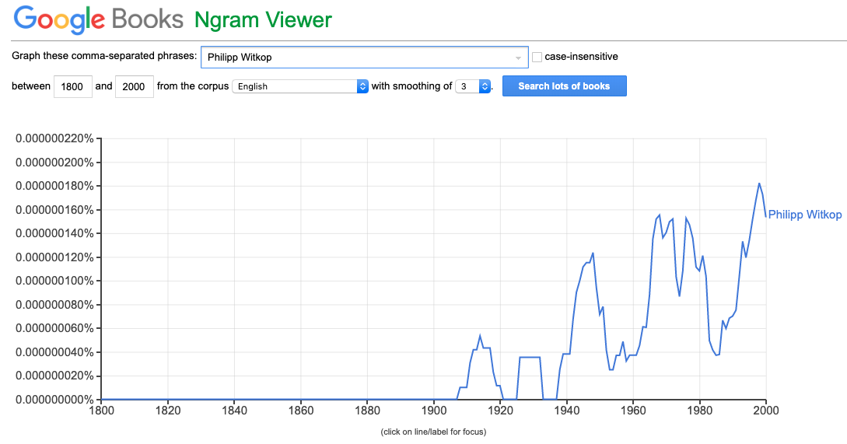

German search in Ngram for ‘Philipp Witkop’

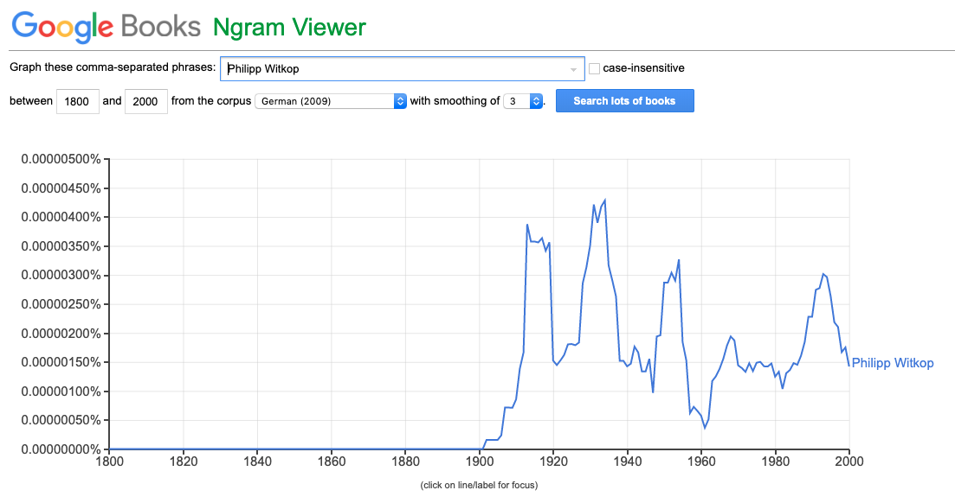

German search in Ngram for ‘Philipp Witkop’ and ‘Kriegsbriefe gefallener Studenten’

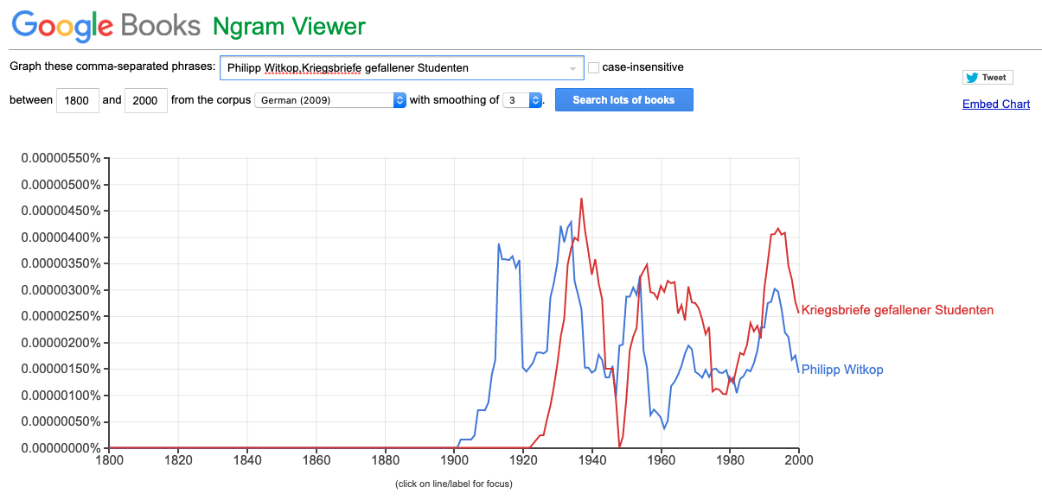

English search in Ngram for ‘Philipp Witkop’ and ‘Kriegsbriefe gefallener Studenten’
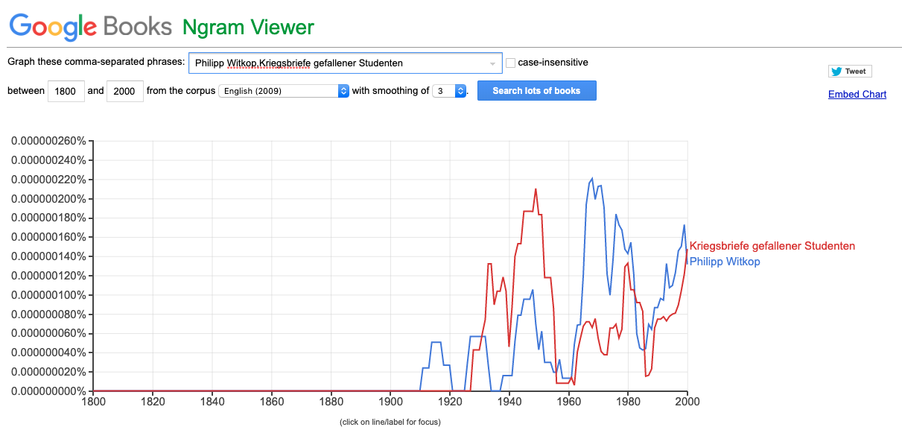

English search in Ngram for ‘Philipp Witkop’ and ‘German Students’ War Letters’

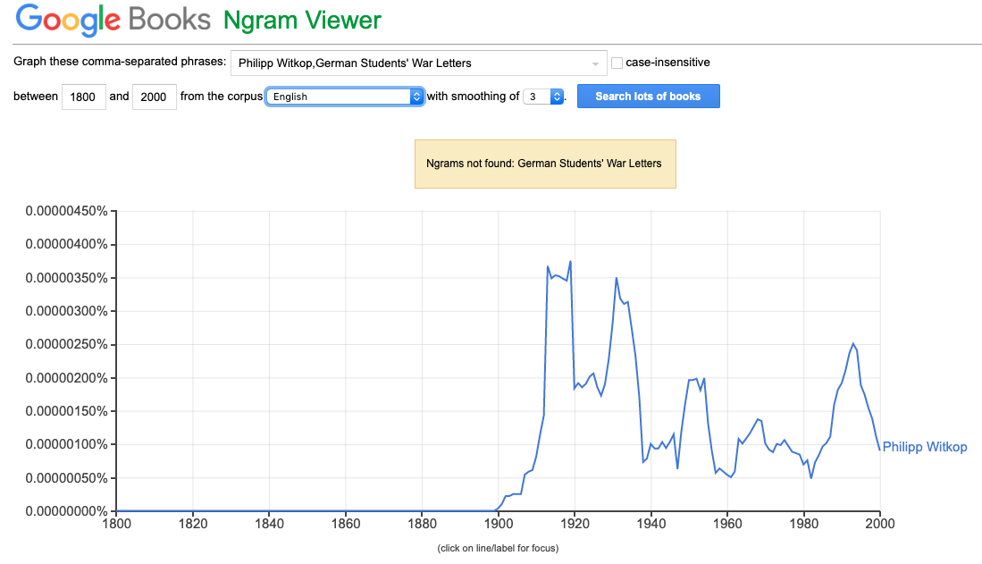

German search in Ngram for ,,Kriegsbriefe”

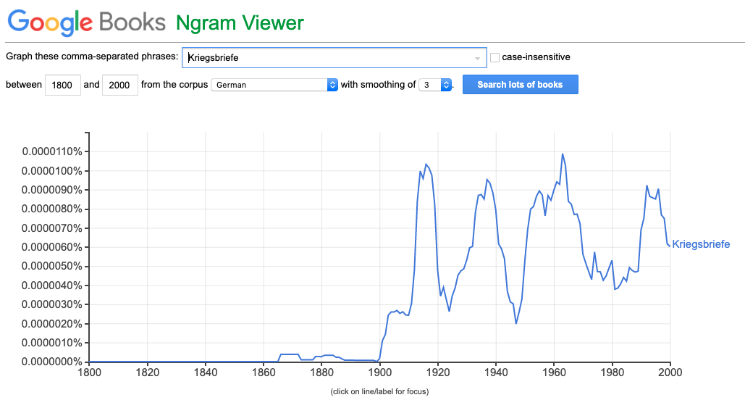

Hettling, Manfred: Witkop, Philipp , in: 1914-1918-online. International Encyclopedia of the First World War, ed. by Ute Daniel, Peter Gatrell, Oliver Janz, Heather Jones, Jennifer Keene, Alan Kramer, and Bill Nasson, issued by Freie Universität Berlin, Berlin 2017-01-25. DOI: 10.15463/ie1418.11040. Translated by: Bradish, Paula.
Hettling. "Witkop, Philipp. https://encyclopedia.1914-1918-online.net/article/witkop_philipp DOI: 10.15463/ie1418.11040
Wittmer, Felix A. Books Abroad 4, no. 1 (1930): 79. doi:10.2307/40046716
Winter, Jay. "FOREWORD: Philipp Witkop and the German “Soldiers’ Tale”." In German Students' War Letters, edited by Witkop Philipp, by Wedd A. F., V-Xxiv. University of Pennsylvania Press. http://www.jstor.org/stable/j.ctt3fj1v1.2.
Knorr. "Philipp Witkop." Lexikon Westflischer Autoren Und Autorinnen 1750 - 1950 Autorenlexikon Autoren. 1995. Accessed May 2019. https://www.lwl.org/literaturkommission/alex/index.php?id=00000003&letter=W&layout=2&author_id=948.

