Nicholas Kmetz
History 133B
Marcuse
March 10, 2016
Unaccredited Father of the Third Empire
Arthur Moeller van den Bruck, “The Third Empire” (1923)
“The Third Empire” or “Das Dritte Reich” by Arthur Moeller van den Bruck (1876-1925) is a book published in 1923, which describes Bruck’s belief that the Weimar Republic was not working for the German people and was the cause of many of the problems that Germans faced. He believed that Germans were destined to unify their nation and create a Third Empire, similar to the empire of Bismarck, but this was only possible if the German people work to make this empire become a reality. They had to become united by the idea of nationalism and reject the influence of liberalism. The original document was written in Germany and can be found on the German History in Documents and Images website under the Weimar Germany tab. Numerous republications of this book in both German and English have been made due to its significance on political philosophy and especially its importance in developing the ideology of the Nazis. Moeller van den Bruck was an intellectual in Germany who edited the works of Fyodor Dostoyevsky and then fought in World War I. After the war, Bruck felt that Germany had too many political and cultural problems and believed that Germany had to be saved from this new modern industrial society.
Moeller van den Bruck is widely cited due to many scholars believing that he was fundamental in the development of nationalism and the future rise of Nazi ideology. Nearly all of these books, reviews, and articles link “The Third Empire” with the rise of the Nazi party and its growth in popularity, due to their similar ideals and hopes for the future of Germany. He even created the name for the coming government the Third Empire or Third Reich. Most scholars within Germany and outside it during the time seem to believe that Nazism owes its roots to the writings of Moeller van den Bruck; however, in many cases the Nazi party denies that Bruck was influential at all to the development of Nazi ideology and instead all of the credit should go to Hitler. Despite the Nazis’ refusal to give Bruck credit for his contributions to German political philosophy, most historians seem to believe that he played an integral part in forming Nazi ideology and their denial was simply propaganda to inflate Hitler’s appearance to the masses. Moeller van den Bruck seems to be universally accepted as an important writer and philosopher for Germany who desperately believed in nationalism and hoped that the German people end the Weimar Republic and start a new empire, which is exactly what the Nazis created.
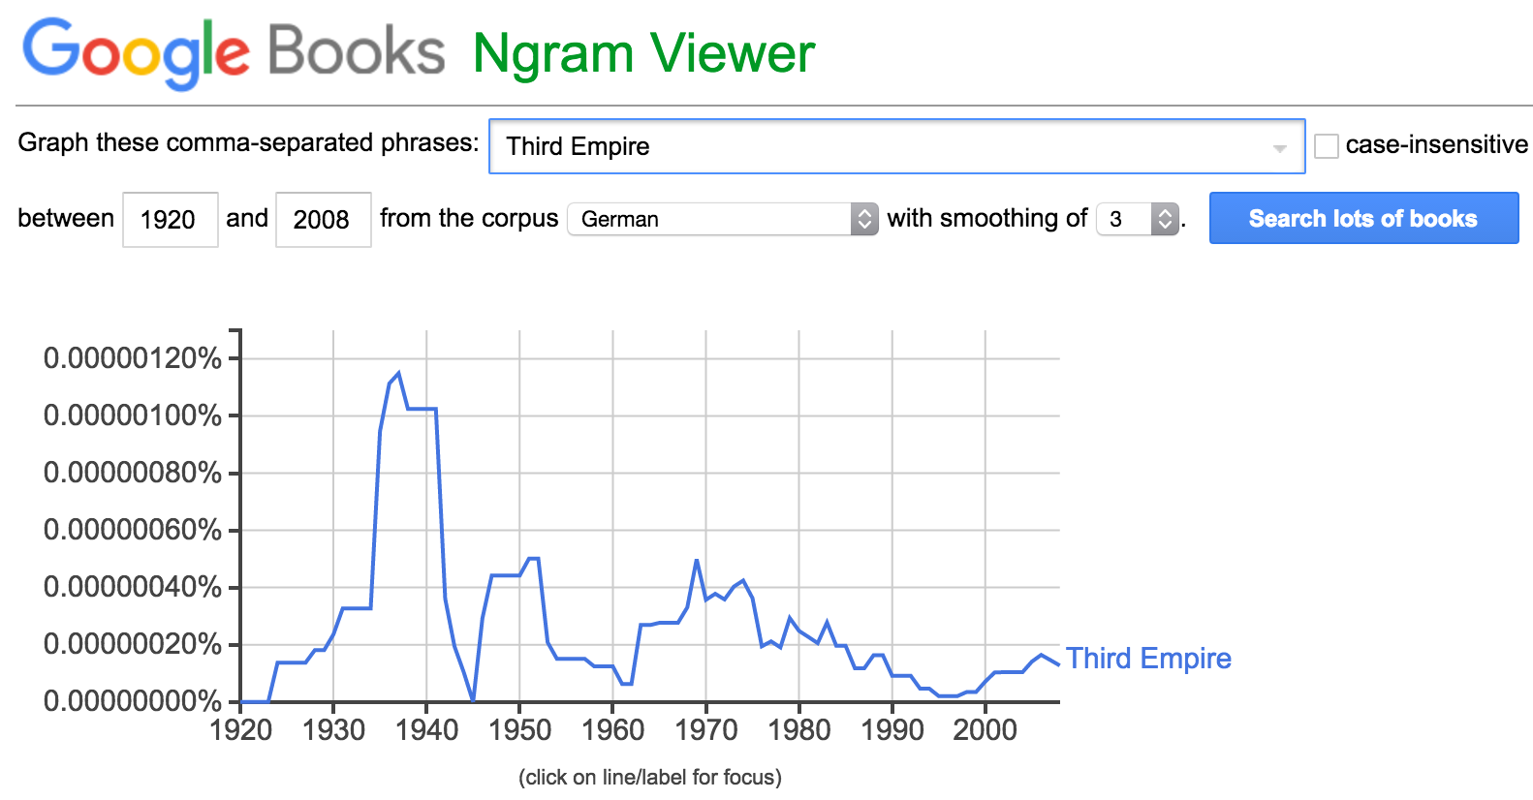Image: Ngram of term ‘Third Empire’ growing in popularity starting in 1923, the year ‘Das Dritte Reich’ was first published.
- Bradley, Phillips. 1933. “Eyes over Germany”. Review of The Crisis in German Democracy.; Germany Puts the Clock Back.; Das Dritte Reich.; German Cities. Social Forces 12 (1). Oxford University Press: 139–42.
  - This is a review of several books, one of which was Das Dritte Reich by Moeller von den Bruck. It discusses how these books led to the development of Nazism and Hitler’s rise to power. The author also claims that this event has been the most startling since World War 1. The author delves deeper into ‘Das Dritte Reich’ and believes that it is an important text for “Hitlerism,” yet the Nazis never recognize Bruck as an important author or philosopher of their cause. The author claims that it is vital to the National Socialists, which the Nazis would later refuse. However since this is a book review from outside of Germany, the Nazis may have not been able to deny this claim.
- Sands, H. (1934, Jul 12). Third German Reich Explained. Los Angeles Times (1923-Current File) Retrieved from http://search.proquest.com/docview/163211850?accountid=14522
  - This article was written nearly ten years after the book was initially published in 1923. The author wrote about how Bruck’s ideas influenced the thoughts of the early radical Nazis. His ideas stemmed from his anger and frustration with the Weimar Republic and his hope that something else would replace it. The biggest idea that the Nazis adopted from him was his use of the term the Third Empire or Third Reich.
- Mueller, Gustav. 1937. Books Abroad 11 (1). University of Oklahoma: 42.
  - Written by a Swiss professor of philosophy after moving to the US before the war. This is a review of Bruck’s book “Das Dritte Reich” and focuses on how that book is a fundamental source in understanding the development of the Nazi party and its ideology because it was written before World War II. Moeller also believes that regardless of what happens to the current regime of Germany, this book will remain an important text in political philosophy; however, the Nazis would at times refuse Bruck’s influence on the Nazi party and instead claim that Nazism was completely envisioned by Hitler.
- Krebs, Gerhard. 1941. Moeller Van Den Bruck: Inventor of the “Third Reich”. The American Political Science Review.
  - Krebs describes Bruck’s early life and many of his influences, mainly Nietzsche, then follows his progression into the writing of nationalist ideology, which pushed for a conservative revolution against the government of the Weimar Republic. He explains that Bruck believed that Germany was not defeated militarily but instead by being tricked by the other nations of the world. He also emphasizes that Bruck believed that a party must rise that is opposed to the older parties, which is something that the Nazis claimed to be. Finally Krebs writes about the similarities of Bruck’s ideology and Hitler’s and while Bruck may have influenced Hitler, Hitler does not acknowledge gaining any ideas from him.
- Kohn, Hans. 1962. “The Nation Was Their Rock.” New York Times. ProQuest Historical Newspapers.
  - This newspaper article, which was written many years after the war ended, talks about Bruck and his book as one of the early major proponents of nationalism in Germany. The author believes that his pessimism concerning modern Germany caused him to turn from idealism to nihilism and it was this ideological shift that allowed Hitler, who the author claims represents realistic nihilism, to gain power.
- Silfen, Paul Harrison. 1971. The Volkisch Ideology and the Roots of Nazism; the Early Writings of Arthur Moeller van den Bruck. Exposition Press.
  - This book tries to find the reason that Germany was in a position that allowed Nazis to exist and flourish. It finds that many of the people within Germany accepted Nazi ideology and that many intellectuals living in the Weimar Republic like Arthur Moeller van den Bruck introduced these ideas. Focusing on the early writings of Bruck, he finds many of the tendencies of the Nazi ideology and its focus on race, the Volk, and German culture and their connection with nature. These ideas are expanded on but not necessarily made concrete in Bruck’s later works.
- Stern, Fritz Richard. 1974. The Politics of Cultural Despair: A Study in the Rise of the Germanic Ideology. University of California Press.
  - This author writes that Moeller was part of a group of intellectuals in pre-WWII Germany that attacked liberalism, Westernization, and secularism that was sweeping through Germany at the time of the Weimar Republic. While he did have ideas that were unique to him, he fits into a group of German writers that expressed similar dissatisfaction with the direction of Germany. He claims that while Moeller did attack “intellectual refuse” of the times, his ideology was unrealistic and had nothing to do with real historical developments. The author believes that, he was not the spiritual founder of the Nazi Party but that many of the leading Nazis were inspired by his words.
- Van Dyke, James. 2013. “Ernst Barlach and the Conservative Revolution.” German Studies Review 36, no. 2: 281-305. Academic Search Complete, EBSCOhost (accessed January 26, 2016).
  - This article explains the relationship between Ernst Barlach (an artist) and the conservative revolution, which also includes his friendship with Moeller van den Bruck. The author claims that Barlach was quite conservative but he did not agree with Bruck’s later writing, and could not even finish “Das Dritte Reich,” evidence of which is found in a letter from Barlach to Karl Barlach in 1932. This shows that other conservatives, who also rejected the Weimar republic and felt that a revolution might be necessary, did not necessarily agree with Bruck and his ideology.

