Berri Bottomley
HIST133C
June 13, 2019
Kronprinzenpalais: Witness to History

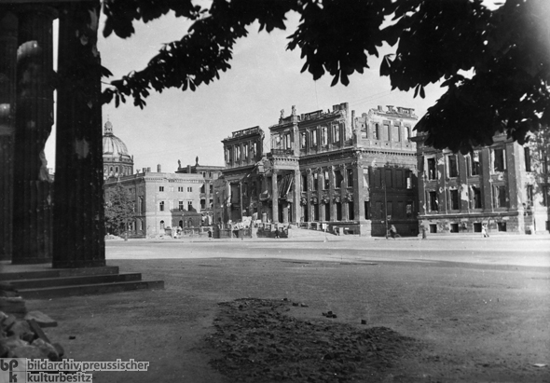
Destroyed Crown Prince’s Palace, Unter den Linden 3 (1946)

The above photograph of the Crown Prince’s Palace (Kronprinzenpalais) at Unter den Linden 3, Berlin, was taken by German photographer Friedrich Seidenstücker (1882-1966) in 1946. The haunting image hints at the building’s prior dignity but does not project hope for its future revival. The building on the right is the Princess’s Palace (Prinzessinnenpalais.)
Kronprinzenpalais
The Kronprinzenpalais has been witness to a long stretch of Prussian and German history. It was constructed as a private house in 1663. In the early eighteenth century it served as a residence for the Governor of Berlin. In 1732 it was converted by architect Philip Gerlach for Crown Prince Friedrich. During the early nineteenth century it was the residence of King Friedrich Wilhelm III. In 1811 a covered bridge was added over Oberwallstrasse, connecting it to the Prinzessinnenpalais. A radical reconstruction was carried out in 1856-57. The mansard roof was removed and replaced by a third story with Corinthian pilasters.
During the Weimar Republic, beginning in 1919, it served as an art museum exhibiting the best of German and European modern art under director Professor Dr. Walter Justi. After 1933 the art it held was banished by the Nazis, Justi was dismissed, and the museum was closed. As shown in the photo, it was badly damaged by bombing in WWII, and was reconstructed in 1968, after which it was used by the East German government as a guesthouse. The Unification Treaty was signed there by Federal Minister of the Interior Wolfgang Schäuble and East German Secretary of State Günther Krause on August 31, 1990. It is now once again used for exhibits and cultural events.
Prinzessinnenpalais
The Prinzessinnenpalais was originally constructed in 1730 as two private houses for high government officials. Facing Oberwallstrasse, which runs perpendicular to Unter den Linden, the houses’ back gardens were bordered by the fortress wall. Only three years later architect Friedrich Wilhelm Diterichs merged the two houses, creating a long, narrow building. In 1788 it came under the ownership of the Hohenzollerns and was used as a residence for the king’s daughters. Between 1931 and 1933 it housed the Schinkel Museum, displaying a collection begun by Frederick Wilhelm IV of the work of artist and architect Karl Friedrich Schinkel (1781-1841). Like the Kronprinzenpalais, the Prinzessinnenpalais was badly damaged in World War II. It was rebuilt in 1962-1964, and the interior was used as an opera café, serving the neighboring Berlin State Opera.
Friedrich Seidenstücker (1882-1966)
Seidenstücker trained as an engineer and sculptor. In the 1930s he became a freelance photojournalist, specializing in scenes of nature and daily life. During WWII part of his personal archive was destroyed by bombs. In the 1950s he withdrew from public life for health reasons but continued his photography with a series of nude studies. He died of a stroke in 1966.

Annotated Bibliography in Chronological Order
Abercrombie, Patrick. “Berlin: Its Growth and Present State.” The Town Planning Review 4, No. 3 (Oct. 1913): 219-233. https://www.jstor.org/stable/40100056
Discusses architectural styles in the growth of Berlin. Explains that Frederick the Great (1712-1786) wanted to glorify Berlin as the capital of his kingdom and had the idea of making Unter den Linden a great avenue ending in a group of public buildings and the Royal Schloss. The remodeled Crown Prince’s Palace was a later addition.
“News in Brief.” The Times (London, England), July 5, 1933, p.13. The Times Digital Archive, http://tinyurl.galegroup.com/tinyurl/9vRuaX
“Professor Waetzoldt (principal director of Prussian State Museums), Professor Ludwig Justi (director of the National Gallery and Kronprinzenpalais collection), and Dr. Friedländer (chief director of the picture gallery in the Kaiser-Friedrich Museum) have been retired from their posts.”
Jewell, Edward Alden. “The Creative Life vs. Dictatorship.” New York Times, August 13, 1939, p. X7. New York Times (1923-Current File) Retrieved from https://search-proquest-com.proxy.library.ucsb.edu:9443/docview/102860581?accountid=14522
“Works exiled from Reich collections and now acquired by the Museum of Modern Art – Freedom in Democracy.” The author, writing in 1939, notes that a decade earlier “many of the big German collections of modern art were magnificent,” including “the Kronprinzenpalais (especially its once ‘radical’ top floor!).”
Der Faszinierende Augenblick: Fotografien Friedrich Seidenstücker 1882-1966 Bildarchive Preussischer Kulturbesitz. (Berlin: Nicolaische Verlagsbuchhandlung, 1987)
“The Fascinating Moment.” A review of some of Seidenstücker’s photography. Includes an article by him titled “How I Started,” and commentary by some of his models and friends. In German.
“Signing the Unification Treaty (August 31, 1990).” German History in Documents and Images. Accessed 5/22/2019. http://ghdi.ghi-dc.org/sub_image.cfm?image_id=3063
Photo by Wolfgang Kumm of signing of Unification Treaty in Kronprinzenpalais.
Deshmukh, Marion. "Recovering Culture: The Berlin National Gallery and the U.S. Occupation, 1945-1949." Central European History 27, no. 4 (Winter, 1994): 411. Accessed 5/22/2019. https://search-proquest-com.proxy.library.ucsb.edu:9443/docview/1297833002?accountid=14522.
In June 1933 Justi was forced to take “indefinite leave, effective immediately.” Several replacements followed: Schardt, Hanfstaengl and Rave. After 1933 no new exhibitions were mounted, and the Kronprinzenpalais, which housed twentieth-century art, was closed. Rave was “cleared by the Allies after the war of possible pro-Nazi sympathies, [and] became the National Gallery’s first post-war director after 1945.”
MacDonogh, Giles. 1998. Berlin. New York: St. Martin's Press.
Book on the city and its history. McDonough writes that the interior of the Kronprinzenpalais is a “modernized baroque which seem[s] to have been inspired more by a high-class brothel than any palatial model.” Includes section on the purging of “degenerate art” which states that Göring liked art and was not convinced that the Kronprinzenpalais included only Jewish painters. Quotes Göring as saying that “It is a great deal easier, given a little time, to make a great painter into a decent National Socialist than to turn a little party member into a great painter.” (Cites quote as from Paul Ortwin Rave, Kunstdiktatur im Dritten Reich, Berlin 1949, 56.)
Stangl, Paul. “Restoring Berlin’s Unter den Linden: Ideology, World View, Place and Space,” Journal of Historical Geography 32 (2006): 352-376.
“Berlin's Unter den Linden, a primary thoroughfare and ensemble of historic architecture and nationally significant cultural institutions, lay in ruins at the close of the Second World War. The buildings, public spaces, and public art forming this street bore testimony to diverse facets of German history, presenting a range of semantic issues to those interested in their future.” Notes that the restoration of other buildings on the street such as the Arsenal and Zeughaus were contested between planners’ desire to preserve architectural heritage and communists desire to “efface” Prussian militarism. The Kronprinzenpalais was among the last restored due to limited resources.
Schunke, Antje. “Seidenstücker, Friedrich.” Deutsche Biographie. 2010. Accessed 5/1/2019. https://www.deutsche-biographie.de/gnd118812009.html#ndbcontent
Brief biography. Says he lost his mobility in the 1950s for health reasons.
Hoffmann, Stefan-Ludwig. "Gazing at Ruins: German Defeat as Visual Experience." Journal of Modern European History / Zeitschrift Für Moderne Europäische Geschichte / Revue D'histoire Européenne Contemporaine 9, no. 3 (2011): 328-50. https://www.jstor.org/stable/26265947.
Article discusses photographs of Berlin ruins, including Seidenstücker’s. Notes that in his photographs “the city appears as an ancient, far-away world, like the ruins of Pompey [sic].” Also notes that Seidenstücker’s work prior to 1933 had featured everyday social life, but that this was not the case in his post-war photography.
Hickley, Catherine, “Widow of Hitler’s Art Dealer, Erhard Göpel, Bequeaths Max Beckmann Works to Berlin.” The Art Newspaper. February 21, 2018. Accessed 5/22/2019. https://www.theartnewspaper.com/news/widow-of-hitler-s-art-dealer-erhard-goepel-bequeaths-max-beckmann-works-to-berlin
Photo of Max Beckmann Hall at the Nationalgalerie in the former Kronpinzenpalais, 1932/33 (© Staatliche Museen zu Berlin, Zentralarchiv; VG Bild-Kunst, Bonn, 2018)
“Kronprinzenpalais.” Wikipedia. Accessed 4/25/2019. https://en.wikipedia.org/wiki/Kronprinzenpalais
The Kronprinzenpalais is a late Neoclassical style building on the end of Unter den Linden. It was a Hohenzollern palace until the end of World War I. It was then an annex of the Berlin National Gallery, housing modern art. Closed by the Nazis, the building was destroyed in World War II. It was rebuilt in 1968 and used as a guest house by the East German government. Since unification it has been used for exhibitions and cultural events.
“Landesdenkmalamt Berlin: Prinzessinnenpalais.” Berlin.de. Accessed 4/25/2019. http://www.stadtentwicklung.berlin.de/denkmal/liste_karte_datenbank/de/denkmaldatenbank/daobj.php?obj_dok_nr=09095951
Gives detailed history of the Prinzessinnenpalais including dates of modifications and reconstruction. Notes that after 1931 it housed the Schinkel Museum.
“Landesdenkmalamt Berlin: Kronprinzenpalais.” Berlin.de. Accessed 4/29/19. https://www.stadtentwicklung.berlin.de/denkmal/liste_karte_datenbank/de/denkmaldatenbank/daobj.php?obj_dok_nr=09095949
Gives detailed history of the Kronprinzenpalais including dates of modifications and reconstruction.
“Friedrich Seidenstücker, 1882-1966.” bpkBILDAGENTUR. Accessed 5/1/2019. https://www.bpk-bildagentur.de/photographers?show=832
Slide show of some of his photographs. Does not include subject photograph.
“Friedrich Seidenstücker.” Wikipedia (German). Accessed 5/1/2019. https://de.wikipedia.org/wiki/Friedrich_Seidenst%C3%BCcker
Brief biography.
“The Heritage.” Das Erbe Schinkels. Accessed 5/22/2019. http://schinkel.smb.museum/index.php?page_id=2
The museum was established when Frederick Wilhelm IV of Prussia purchased Schinkel’s estate in 1842. It was one of the first museums dedicated solely to one artist. It was housed in various buildings, including being housed at the Prinzessinnenpalais from March 1931 until 1933.

Additional Images
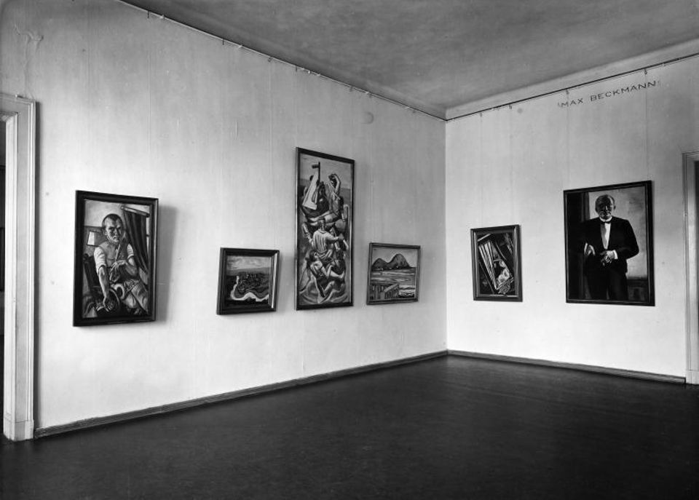
Photo of Max Beckmann Hall at the Nationalgalerie in the former Kronpinzenpalais, 1932/33 (© Staatliche Museen zu Berlin, Zentralarchiv; VG Bild-Kunst, Bonn, 2018)
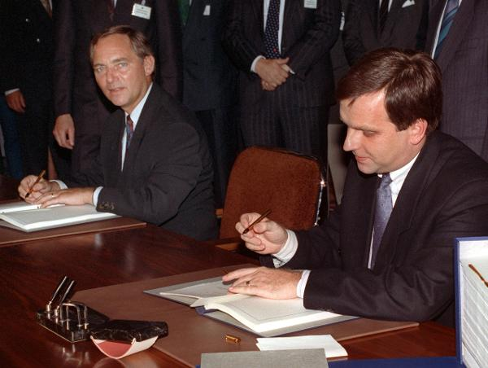
Federal Minister of the Interior Wolfgang Schäuble (left) and East German Secretary of State Günther Krause (right), signed the Unification Treaty in East Berlin’s Kronprinzenpalais, August 31, 1990. (c) dpa-International

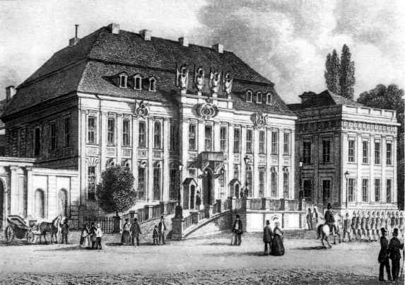 Circa 1856. From Wikimedia Commons
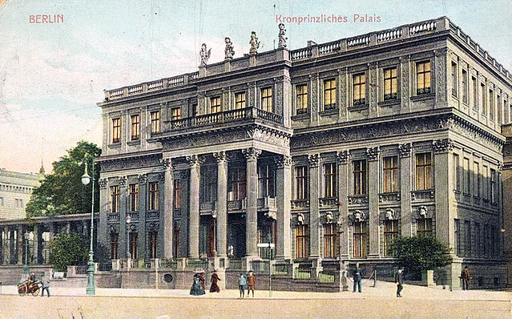 Circa 1890. From Wikimedia Commons

1946. Friedrich Seidenstücker.

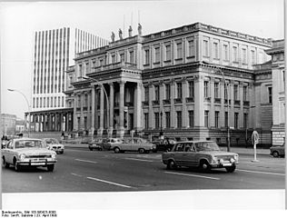 1980. From Wikimedia Commons.

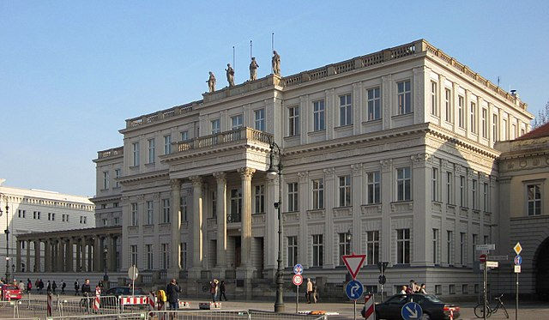 2011. From Wikimedia Commons

“Destroyed Crown Prince’s Palace, Unter den Linden 3 (1946).” German History in Documents and Images. Accessed 5/1/2019. http://ghdi.ghi-dc.org/sub_image_s.cfm?image_id=1189 Photograph by Friedrich Seidenstücker, Berlin, 1946. From vintage print, 13 x 18 cm, gelatin silver. Sourced from Bildarchiv Preussischer Kulturbesitz.
“Landesdenkmalamt Berlin: Kronprinzenpalais,” Berlin.de, Accessed 4/29/19, https://www.stadtentwicklung.berlin.de/denkmal/liste_karte_datenbank/de/denkmaldatenbank/daobj.php?obj_dok_nr=09095949
Giles MacDonogh, Berlin (New York: St. Martin's Press,1998), 386.
“Landesdenkmalamt Berlin: Kronprinzenpalais.”
“Signing the Unification Treaty,” German History in Documents and Images, Accessed 6/6/2019, http://germanhistorydocs.ghi-dc.org/sub_image.cfm?image_id=3063.
“Landesdenkmalamt Berlin: Prinzessinnenpalais,” Berlin.de, Accessed 4/25/2019, http://www.stadtentwicklung.berlin.de/denkmal/liste_karte_datenbank/de/denkmaldatenbank/daobj.php?obj_dok_nr=09095951
“Friedrich Seidenstücker,” Wikipedia (German), Accessed 5/1/2019, https://de.wikipedia.org/wiki/Friedrich_Seidenst%C3%BCcker

