Josh Grigsby
Marcuse, Harrold
Hist. 133C, Source Exploration
June 12, 2019
- “Lastenausgleich heißt Vermögensausgleich!” [“Equalization of Burdens Means Equalization of Wealth”], Der Leuchtturm, 1948, no. 5, 66f; reprinted in Christoph Kleßmann and Georg Wagner, Das gespaltene Land. Leben in Deutschland 1945-1990. Texte und Dokumente zur Sozialgeschichte [The Divided Land. Life in Germany, 1945-1990. Texts and Documents of Social History]. Munich: C.H. Beck, 1993, pp. 106-07
[Headnote]: The focus of this report explores the history and development of a wealth adjustment policy that was discussed throughout the devastated European countries following WWII. The purpose of enacting such a policy was to seek out fair recompense for those who had suffered great financial losses that resulted from the war, the foremost being those who were arbitrarily bombed out during hostilities. In practice, that meant wealth would need to be levied from to those who were lucky enough to retain their assets, and distributed to those who were not so fortunate. The German term for this policy is Lastenausgleich, which means equalization of burdens. Even though it was debated broadly in most of Europe’s war-torn countries, only two of them actually implemented it. One was Finland, whose economy was built around agriculture, which made the implementation much smoother. The other was West Germany, who encountered numerous obstacles before they were able to pass their Lastenausgleich legislation. The main primary source that this report is centered around was written during a period of uncertainty that such a law would even pass. It was taken from a West German periodical, published in 1948 and later put into the GHDI website database. This western German magazine article, The Equalization of Burdens Means the Equalization of Wealth, argues in favor of implementation of this policy. The central argument of this piece is that the repercussions of the war should be felt by all to prevent future warfare. Furthermore, in contrast to what their opponents were claiming this article made the case that Lastenausgleich would strengthen property rights, a key point of distinction between them and their communist neighbors to the east. There was popular support for this policy in West Germany, and it did indeed finally win out as it came into effect September 1, 1952. Although search results regarding the background information of this particular author were mostly inconclusive, other avenues, such as following other sources that have cited this work or wrote about this topic did shed a good deal of light on this subject. In so doing, I uncovered a host of unexpected factors that were weighing on the debate for equalization that I had not expected. One surprise was that the concept itself first took root under the Nazi regime. They worked to promote a sense of shared sacrifice, putting nation above individual concerns. Also of interest the research that examined the unintended consequence of not putting forth an equalization policy after the First World War. With the huge burden of the war not equally distributed, angry elites worked to destabilize the government. This disaffected group became a significant factor in the fall of the Weimar Republic. This epic failure by the Weimar government in handling the debt crisis of the first war continued to resonate with Germans even after the Second War. Moreover, its memory was used to rally political support by the Lastenausgleich coalition in the years that followed the Nazi demise.
Nazi Promise of Equalization Fulfilled
A government policy that redistributes wealth from those who have to those who have not, might seem more agreeable to the camps pushing for a left-leaning socialist or communist agenda, but the debate in postwar Germany did not break down along those lines. It was in fact the US bloc in Western Germany who took the strongest position in support of a legislative fix to the inequality crisis caused by years of warfare. Prior to The Age of Enlightenment in the 18th century, wars were thought of as religious acts, and those who suffered damages of wartime fighting had no recourse against the will of god. Modern liberal thinkers challenged this notion, and as a result the door was opened to the idea that people could be held responsible for human made wars. Moreover, capitalism relies on an active government, willing and able to intervene when necessary to restore and protect private property. Therefore, if citizens were allowed lose their life savings because of poor government decisions, the concept of private property loses its value. Voices in the East who wanted to socialize the means of production argued against Lastenausgleich for similar reasons. Individual property rights did not fit with what they wanted to build in the East and felt that private companies would be able to use the issue to torpedo their socialist agenda. In 1947, according to an East German newspaper, Tagliche Rundshau, “It is especially organs of the SPD that are advocating such a solution;” which raised the important question, who was behind Lastenausgleich, and why? The article continues, “but bourgeois circles have also recommended such measures in no small number of cases,” highlighting the fact that the SPD and the capitalist both wanted the same ends.
Another argument put forward by the proponents of Lastenausgleich was the fallout from the financial policies that took place following WWI. Just after the war, the German government inflated the currency to the point of making it effectively worthless, allowing them to pay off their huge wartime debts. However, this inflation meant that the cost of the war was borne primarily by one segment of the German population, savers. Similar to the indiscriminate bombing that devastated some homes and left others untouched during the second war, the hyperinflation after WWI was also unequally felt by the population. Those who held paper money became destitute, while the segment of society that had non-liquid assets (Land) retained most of their wealth. Not surprisingly, these former currency-holding elites were furious with the Weimar Republic for putting the cost of the war onto them. Furthermore, because the burden was not shared equally, the conditions were created for Hitler to court those disaffected elites and gain their support. Given Germany’s recent failure during the Weimar Republic to treat all its citizens fairly, peoples’ willingness after WWII to support some sort of equalizations found a far more receptive audience out of fear of repeating the same mistake twice in one lifetime.
Further exploration concerning the reasons why Lastenausgleich found success in the West, but not the East could have something to do with its origins. The Nazis came to power on promises of restitution for individuals as well as restoration of Germany as a world power. In order to keep the German civilian population from rejecting the huge burden of another war, the Third Reich promised it would make citizens (those whom Nazis identified as racially German) whole again. Claims of war damages were cataloged with the Nazi government to be paid at a later date. The Nazis believed either the forced labor of non-Germans would pay off these debts in a victorious Nazi Germany, or complete destruction if they lost, in which case huge debt didn’t seem to matter much. Being that Lastenausgleich originated as a Nazi concept, it’s no wonder that the East, which made a concerted effort to purge its checkered Nazi past, had little appetite to enact such a policy. However, the West’s rejection of Nazism was far more superficial, as they allowed many former Nazi members to serve in high posts in the new administration, and consequently they seemed more receptive to the issue.
An important aspect of Lastenausgleich and a surviving legacy of Nazi Germany is communalism. Far from being just lip service to angry creditors, central to Nazism was building communities tied together by a sense of shared sacrifice, which could then be transferred to a nationalist agenda. We saw this in the Nazi youth movement of the 1930s, as they promoted communal values to adolescents. Moreover, these communal values instilled by the Nazi regime did not disappear in 1945 when it lost power. Communalism was a key part of the eventual success of Lastenausgleich in West Germany. According to Michael L Hughes in Shouldering the Burdens of Defeat, “War damaged individuals were successfully deploying Nazi-promoted notions of communal obligation to compel the undamaged to acknowledge the need for postwar sacrifices” in an effort to gain public sympathy and push for a national response.
The exploration of primary sources from both East and West Germany, as well as Michael Hughes’s scholarly analysis, sheds light on an interesting past that was expressed through the move to recompense the war damaged. It is revealed that communal values and nationalism collided with individual property rights in this single policy to equalize the cost of the war. Politicians in the West took up the cause for equalizations to prevent the backlash that might get in the way of their capitalist goals. The East rejected Lastenausgleich like they distanced themselves from other Nazi programs. In the end, it appears that both made the appropriate decision for what their proposed goals were.

Charts Below: Upper> “Lastenausgleich” (The German term spikes in the 1980s).
Lower> “Equalization of Burdens” (English term spikes around 1959).
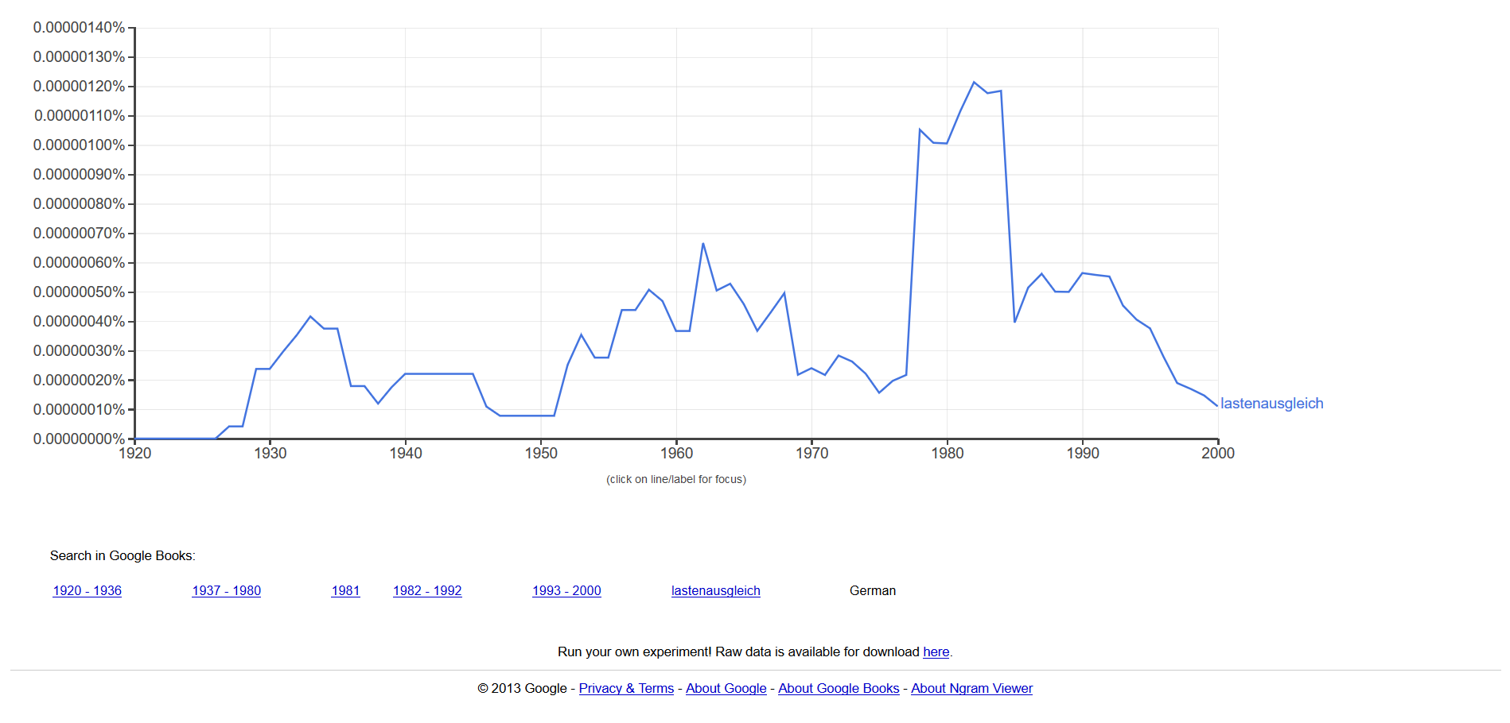
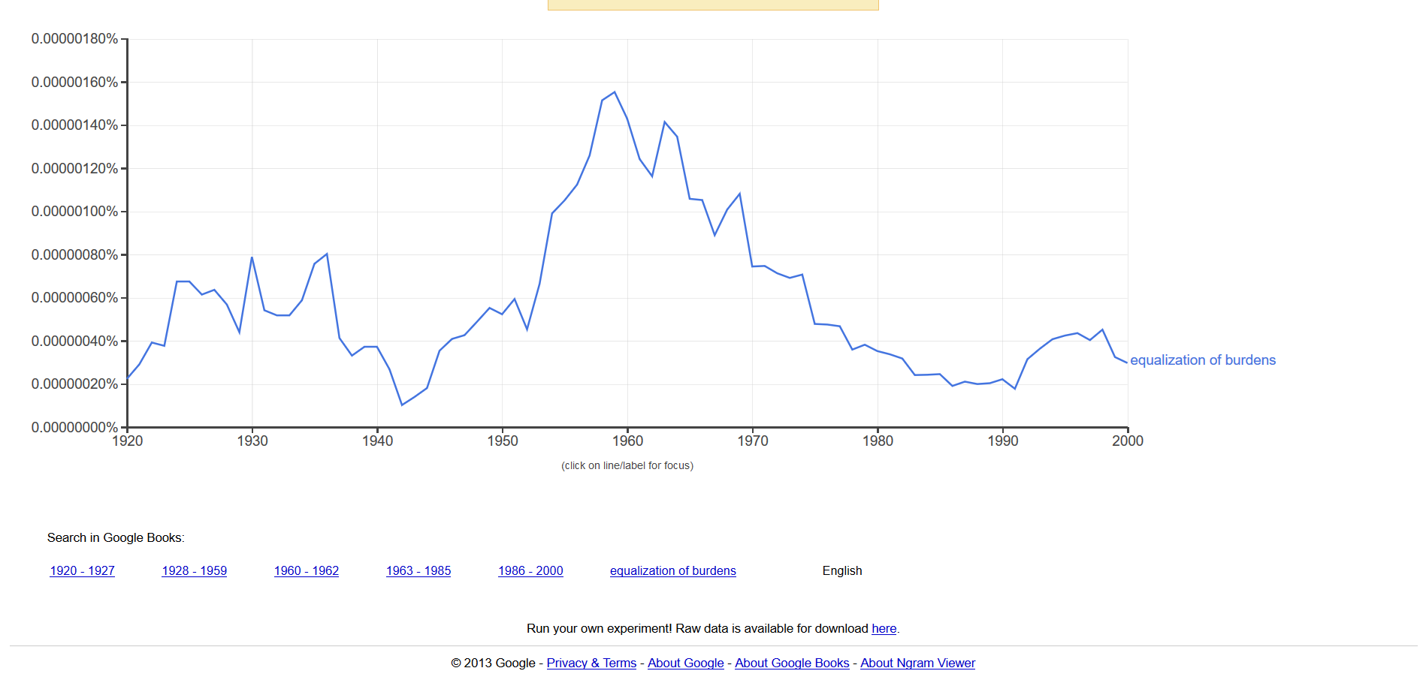
Annotated Bibliography in Chronological Order
1“Lastenausgleich heißt Vermögensausgleich!” [“Equalization of Burdens Means Equalization of
Wealth”], Der Leuchtturm, 1948, no. 5, 66f; reprinted in Christoph Kleßmann and Georg
Wagner, Das gespaltene Land. Leben in Deutschland 1945-1990. Texte und Dokumente zur
Sozialgeschichte [The Divided Land. Life in Germany, 1945-1990. Texts and Documents on
Social History]. Munich: C.H. Beck, 1993, pp. 106-07.
This pro Lastenausgleich West German magazine article argues that the burden of the war
should be felt by all Germans in a fair, just and proportional manner. Warns that if this is
not the case, the destructive lessons of going to war might not be learned by certain
segments of the population not impacted. Also, believes Germans have no right to shift
the cost of war toward future production to the next generation that did not cause the
mess. Furthermore, argues that if nothing is done, people will be pushed in the direction
of communism.
2. “Lastenausgleich durch Naturalausgabe? Ein Zankapfel als Ablenkungsmanöver der Reaktion”
[“The Equalization of Burdens through Restitution in Kind? A Bone of Contention as a
Diversionary Tactic of the Reactionary Contingent”], Tägliche Rundschau, no. 39, February
15, 1947; reprinted in Udo Wengst, Geschichte der Sozialpolitik in Deutschland, Bd. 2/2:
1945-1949: Die Zeit der Besatzungszonen. Sozialpolitik zwischen Kriegsende und der
Gründung zweier deutscher Staaten. Dokumente [The History of Social Policy in Germany,
Vol. 2/2: 1945-1949. The Era of the Occupation Zones. Social Policy between the End of
the War and the Founding of Two German States. Documents]. Baden-Baden: Nomos,
2001, no. 132, pp. 285-87.
This East German newspaper article argues against a government mandated equalizations act.
The rejection is grounded in the theory that this policy would divide East Germany and
derail its goal to socialize industry. Not only does the article argue Lastenausgleich would be a distraction, it questions its usefulness to those who would be receiving the levied goods likely to be in poor condition.

3. Hughes, Michael L. Shouldering the Burdens of Defeat: West Germany and the Reconstruction
of Social Justice. Chapel Hill: University of North Carolina Press, 1999. P 40 In this detailed investigation into the equalization debate that surrounded Germany in
the wake of WWII, Hughes traces the origins of Lastenausgleich back to its Nazi past. He
contrast it against the Weimar Republic’s failure to share the cost of WWI equally among
Germans at that time, and how that influenced post WWII Germans to avoid that mistake.
Hughes also takes a look at some of the key figures that helped bring this policy to fruition
such as Ludwig Erhard and Konrad Adenauer. He also walks through the many challenges
that those who pushed for equalizations were up against. For starters, they had no
government to lobby after the war in an occupied state. Also, complications such as the
émigrés and what to do with them when figuring out the best way to implement such a
vast undertaking.

“Lastenausgleich heißt Vermögensausgleich!” [“Equalization of Burdens Means Equalization of Wealth”], Der Leuchtturm, 1948, no. 5, 66f; reprinted in Christoph Kleßmann and Georg Wagner, Das gespaltene Land. Leben in Deutschland 1945-1990. Texte und Dokumente zur Sozialgeschichte [The Divided Land. Life in Germany, 1945-1990. Texts and Documents on Social History]. Munich: C.H. Beck, 1993, pp. 106-07.
“Lastenausgleich durch Naturalausgabe? Ein Zankapfel als Ablenkungsmanöver der Reaktion” [“The Equalization of Burdens through Restitution in Kind? A Bone of Contention as a Diversionary Tactic of the Reactionary Contingent”], Tägliche Rundschau, no. 39, February 15, 1947; reprinted in Udo Wengst, Geschichte der Sozialpolitik in Deutschland, Bd. 2/2: 1945-1949: Die Zeit der Besatzungszonen. Sozialpolitik zwischen Kriegsende und der Gründung zweier deutscher Staaten. Dokumente [The History of Social Policy in Germany, Vol. 2/2: 1945-1949. The Era of the Occupation Zones. Social Policy between the End of the War and the Founding of Two German States. Documents]. Baden-Baden: Nomos, 2001, no. 132, pp. 285-87
Hughes, Michael L. Shouldering the Burdens of Defeat : West Germany and the Reconstruction of Social Justice. Chapel Hill: University of North Carolina Press, 1999. P 40

