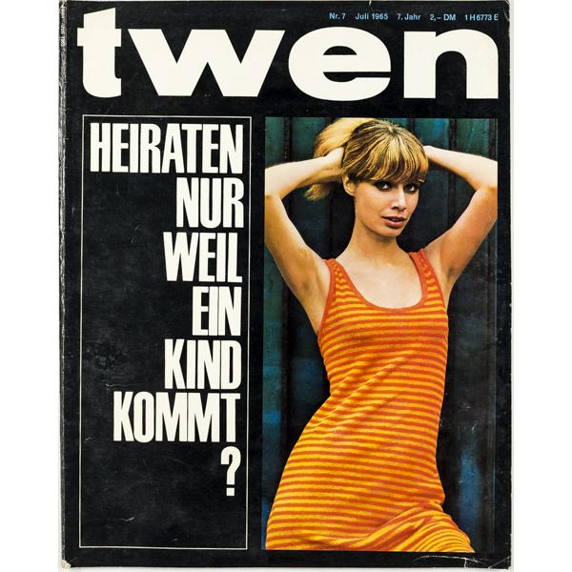

Arianna Dias
Professor Marcuse
How Much Does a Date Cost?
Hist 133c
May 23, 2019

Source: "How Much Does a Date Cost." GHDI - Document. Accessed May 01, 2019. http://germanhistorydocs.ghi-dc.org/sub_document.cfm?document_id=4603&language=english.
- Klaus Bresser, “How Much Does a Date Cost?” [“Was kostet ein Rendezvous?”], Twen, August 1959, pp. 2-22.
- Translated by Thomas Dunlap

For this assignment I chose to go in depth of the article, “Was kostet ein Rendezvous?” or in English, “How much does a date cost.” This article was written in 1959 for the magazine Twen that described how much young men from western Germany were spending on dates during that time period. This article followed thirty young males for one month and added up their total expenditures. One participant stated, “I never was entirely aware of how expensive girls actually are.” The results showed that they spent around DM 20 to 150 a month. Below is a break down of the cost of a date from one participant.

An agreement between all the participants what that having a stable girlfriend keep the prices lower. However when the idea of a girl paying a portion came up, the group was divided. Some said that they would happily accept their girl paying for a portion. Although some participants disagreed and stated they would always pay. In addition, they all agreed that having a girlfriend was expensive in the long run.

COST IN 1959 | CONVERSION | IN 2018
10.50DM | 2.50USD | 21.50USD
10.50DM | .89EURO | 4.54EURO

This article was written by Klaus Bresser. He was born on July 22, 1936 in Berlin Germany. He attended the university of Cologne. He works as a journalist for German Broadcasters. In 1965 he began working for Westdeutscher Rundfunk, which is a German public broadcasting center which puts out radio shows and television shows alike. Then in 1977 he began working for ZDF another broadcasting center. He still works there today according to Wikipedia. He has won a few awards for his journalism. He is the author of three books, What now, dear voters? : the German parties, their candidates and their goals in 1994 [Was nun, liebe Wähler? : die deutschen Parteien, ihre Kandidaten und ihre Ziele 1994] , Deutsche Verlags-Anstalt, Stuttgart 1994, What now? : about television, morality and journalists [Was nun? : über Fernsehen, Moral und Journalisten] , Luchterhand-Verlag, Hamburg 1992, and Sunday Talks [Sonntagsgespräche] , Knaur-Verlag, Munich 1998.
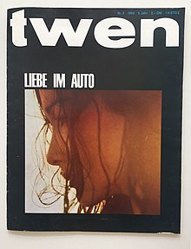
The article by Klaus Bresser was originally published in Twen magazine, which was a popular German magazine aimed at the younger generations ages 15-30. The magazine was originally published from 1959-1971 in western Germany. However one can still find issues later on in the 90s. There has been some dispute over who wrote and published the magazine. Some sources cite Hans A. Nikel and Hans Hermann. However some sources cite two other names, Adolf Theobald and Stephen Wolf.
*To the right is a cover from the year 1963.*
An article from 2013 was published online called “Twen – The Most Influential Magazine of All Times?” As stated in the article the magazine had, “groundbreaking design ideas, innovative usage of photography and full use of the advanced printing methods that made Twen a leader in magazine layout and design.” This article sources Willy Fleckhaus as the art director of Twen. He was described as using images in an innovative way, making history. According to this article, Twen was one of the first to use a “blue ‘shined’ ink underneath process black to give the richness to the page.” Unfortunately within a decade the readership died out, and this version of Twen was “folded” in early 1971.
There is not much history I can find on this magazine, in fact about three different websites said the exact same thing as the wikipedia article. After searching for a while I was able to find copies of the magazine for sale. You cannot find them on ebay, but special vintage stores. On ELEGANTLY PAPERED one copy is being sold for $106.47. In 1965 it was sold for 2,20 DM.
It looks like the article “Was kostet ein Rendezvous?” was only published in twen magazine, then later published on the GHDI website. Google searches do not turn up any different results. This article yields slim results on the internet.

Compare and contrast:

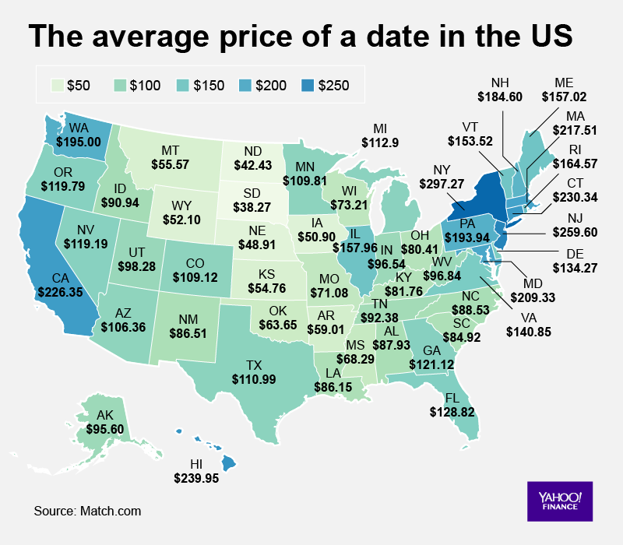
According to TRIBUNE MEDIA WIRE in the year 1959 a date in America compared to a date in 2016.

Absolute Price (what you would have paid back then)
Price of dinner for two: $8.66
Price of two movie tickets: $1.02
Total price of dinner and a movie for two: $9.68

Inflation-Adjusted Price (amount you would have to spend today)
Price of dinner for two: $71.04
Price of two movie tickets: $8.37
Total price of dinner and a movie for two: $79.40

According to Yahoo Finance, in 2018, states a date can cost about $102. (Source: Match.com)
Bibliography

DiPalma, Brooke. "Map: A Look How Expensive Dating Is across U.S. States." Yahoo! Finance. August 20, 2018. Accessed May 01, 2019. https://finance.yahoo.com/news/gave-look-expensive-dating-across-u-s-states-200617454.html.
- An article giving information about the current prices of dating in the United States.

"Here's the Average Cost of a Date the Year You Were Born." WGN. April 08, 2016. Accessed May 01, 2019. https://wgntv.com/2016/04/08/heres-the-average-cost-of-a-date-the-year-you-were-born/.
- An article incorporating different decades throughout history and the prices, including inflation, for going out on a date.

Nikola. "Twen – The Most Influential Magazine of All Times?" Magazine Designing. June 26, 2013. Accessed May 01, 2019. http://www.magazinedesigning.com/twen-the-most-influential-magazine-of-all-times/.
- an op-ed article talking about the layout and design of the magazine Twen.

Timothy Scott Brown (10 October 2013). West Germany and the Global Sixties: The Anti-Authoritarian Revolt, 1962–1978. Cambridge University Press. p. 126. ISBN 978-1-107-02255-3. Retrieved 26 April 2017..

"Twen Magazine: 1959-1970 Many designers will be... | Type Worship: Inspirational Typography & Lettering". Blog.8faces.com. 14 June 2016. Retrieved 25 April 2019.
- a blog post about the layout and typography of twen magazine.

https://en.wikipedia.org/wiki/Twen
DiPalma, Brooke. "Map: A Look How Expensive Dating Is across U.S. States." Yahoo! Finance. August 20, 2018. Accessed May 01, 2019.
"Here's the Average Cost of a Date the Year You Were Born." WGN. April 08, 2016. Accessed May 01, 2019.

