Luis Aguilera
Hist 133C
Source Exploration Version 2
- The source I chose is the Aide-Memoire from Premier Nikita Khrushchev to US President Kennedy, Vienna, June 4, 1961, in the course reader. It is a translation by the Department of State.
- I found the text “Documents on Germany 1914-1961” on the fourth floor of the library. It had the same text as in the reader. It has the same format and reads the same word for word. Premier Khrushchev handed this aide-memoire to President Kennedy during their meeting at Vienna. The text comes from the Department of State Bulletin, Aug. 7, 1961, p. 231. However, it is just a copy of the document so no additional information is provided besides what is already in the course reader. I searched in Melvyl as a journal title and found no results.
- Google Scholar
Key Terms: Aide-memoire from Soviet Union to US, Vienna, June 4, 1961
- Found the website for the US Department of State, Office of the Historian
- History.state.gov/historicaldocuments/frus1961-63v14/ch2
- Documents on the Summit Conference in Vienna, June 3-4
- It includes Russian and Western responses and conversation.
- 32. Memorandum of Conversation, Vienna, June 4, 1961, 10:15am
- There were various persons present including interpreters
- Khrushchev emphasizes; 16 years after war and still no peace treaty, USSR lost over 20 million people and areas were devastated.
- West does not want peace treaty because they would be forced to remove occupation from West Berlin, which was considered against their “national interest”
- Khrushchev emphasizes that if the US does not sign a peace treaty with Germany, it will be signed unilaterally. A state of war would cease to exist, requiring the US occupation to leave. If they do not, the Soviet Union would be forced to “defend” the GDR’s borders. All of Berlin was considered GDR territory.
- Kennedy claims that the US is there because of previous contractual agreements and departure from that area would isolate the US from Europe.
- Kennedy wanted to improve relations without altering the U.S. position in Europe.
- Neither side trusted each other.
33. Memorandum of Conversation, 3:15pm, June 4, 1961:
-Peace treaty and its ultimatum brought up again.
However, Khrushchev says a interim agreement would be agreeable where the German people would decide what happened in Germany once occupation powers left. (6-month time limit)
- Kennedy said it would be a cold winter.
- Khrushchev states that the Aide-memoire on the Berlin Question had been prepared so that the US could study the Soviet position and perhaps return to the question at a later date when agreements could be made.
- Google Books:
- Keywords: aide memoire from Khrushchev to Kennedy
- Google EBook- The Vienna Summit and its importance in International History.
- Bischof, Gunter, Stefan Kramer, and Barbara Staelzi-Marx. 2014. The Vienna Summit and its importance in International History. Langham: Lexington Books.
- Khrushchev “bullied and threatened the unprepared Kennedy”(p. 43)
- Kennedy was under medication for chronic back pain
- Kennedy admits acting unwisely and Khrushchev’s ultimatum had forced the two powers into the most potentially dangerous confrontation since the 1950s.
- The book refers to the fact that despite Russian boasts and confidence, the military balance was moving against the Soviet Union and the communist position was deteriorating in Berlin.
- Some scholars blame the Vietnam War and the Cuban Missile Crisis in 1962 on Kennedy’s poor performance in Vienna.
- However, the editors acknowledge that lessons were learned from the summit: difficult to expect results from a 2-3 day summit and complicated international problems cannot be solved quickly, they require time to overcome obstacles one by one.

- General Web:
Wikipedia:
Entry- Vienna Summit
-Kennedy had just become president and Khrushchev was determined to show his superiority over the US president
-Discussions of a range of topics but Berlin discussions dominated
- Kennedy refused to let his hand be forced to sign a peace treaty that would block access to Berlin despite Khrushchev threatening that there would be war if he did not sign.
- Kennedy’s poor performance during the summit may have been due to the combination of powerful medication he was taking for his back pain and other ailments. Following the prescriptions of Max Jacobson (informally known as "Dr. Feelgood"), Kennedy was injecting himself with a drug cocktail that included hormones, steroids, animal organ cells, vitamins, enzymes, and amphetamines. Among the possible side effects of this combination were hyperactivity, nervousness, impaired judgment, sex drive issues and wild mood swings.^{[7]} (^ Kempe, Frederick (2011). Berlin 1961. Penguin Group (1961). p. 213. ISBN 0-399-15729-8.) This is the reference used by Wikipedia and cited at the end of the entry for the Vienna Summit.
Entry- Bay of Pigs Invasion
- Khrushchev saw Kennedy as inexperienced because of the Bay of Pigs,
“The failed invasion strengthened the position of Castro's administration, who proceeded to openly proclaim their intention to adopt socialism and strengthen ties with the Soviet Union. This led eventually to the events of the Cuban Missile Crisis of 1962. The invasion was a major embarrassment for U.S. foreign policy. John Kennedy ordered a number of internal investigations. Across much of Latin America, it was celebrated as evidence of the fallibility of U.S. imperialism.”
This information from the Wikipedia entries mentioned above all seems accurate. In my research into more scholarly sources, much of the information is confirmed, if not all of it.
4 & 5)
- Melvyl
Key Terms: Khrushchev, Kennedy, 1961
- Gaddis, John Lewis. We Now Know: Rethinking Cold War History. Oxford: Clarendon Press; New York: Oxford University Press, 1997.
- Soviet Union achievements in military technology overshadowed its failures in politics at the time
- Khrushchev did not want or think that the Soviet Union could survive a nuclear war. He tried to bluff the US into backing down
- “Three problems…. it depended on keeping Moscow’s actual nuclear missile capabilities secret, so that his adversaries would not know he was bluffing; it required controlling allies like Ulbricht and Mao, who confused the Soviet Union’s real strengths with Khrushchev’s rhetoric, it assumed that the United States and its allies would take no countervailing measures.”(p. 223)

- Academic Search Complete
Key terms: Khrushchev 1961, Vienna
“Jack Kennedy and Dr. Feelgood” by Peter Carlson
- Kennedy had heard about Max Jacobson who had been known for having “magic potions” that left patients feeling full of energy. The treatments included doses of amphetamines. People question whether these drugs may have affected Kennedy during a time where tensions were high over potential nuclear war.
UCSB Article Database: New York Times 1851-2009
-249 results beginning in May of 1961
- I went through the first few pages of results and most are criticisms on how the Summit went and about the increased tensions of the time that were seen as a result of Kennedy’s and Khrushchev’s conduct at the Vienna Summit.

- Scholar.google.com
Key Terms: Khrushchev, Kennedy, 1961, Berlin
Book
- Kempe, Frederick. Berlin 1961: Kennedy, Khrushchev, and the most dangerous place on Earth. New York: G.P. Putnam’s Sons, 2011.
- Talks about the high tensions in Berlin and the potential for nuclear war
- Discusses various orders given by Khrushchev and Kennedy regarding Berlin and the areas near the Berlin wall.
- Discusses roles of key figures and focuses more on the Berlin Crisis of 1961 but does mention Khrushchev and Kennedy not really understanding each other. This heightened tensions and increased the chances of nuclear disaster.
- Google Ngram
- Key terms: Khrushchev, Kennedy, nuclear war
- Smoothing of 3
- American English:
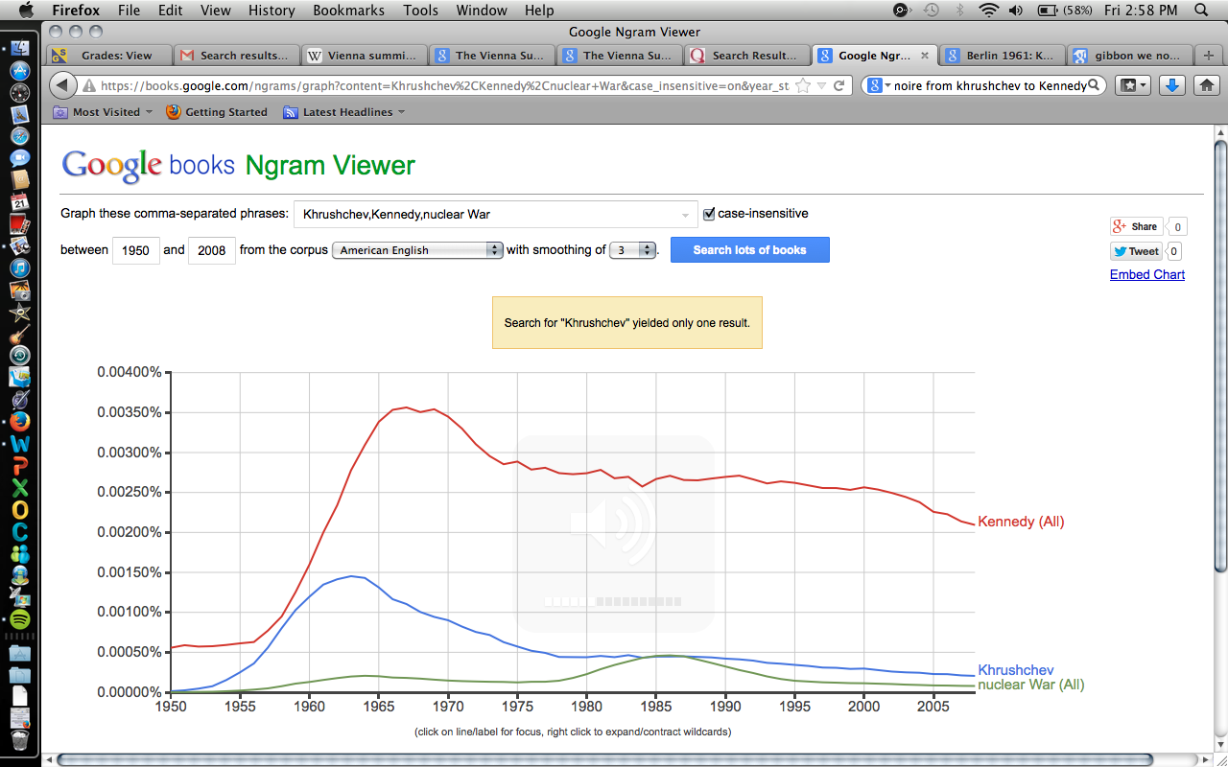
- Spike around the Vienna Summit in 1961 when tensions began to increase between the Soviet Union and the U.S. There is a decrease in both but then remains somewhat constant.
- Nuclear War Ngram below (Smoothing of 1):
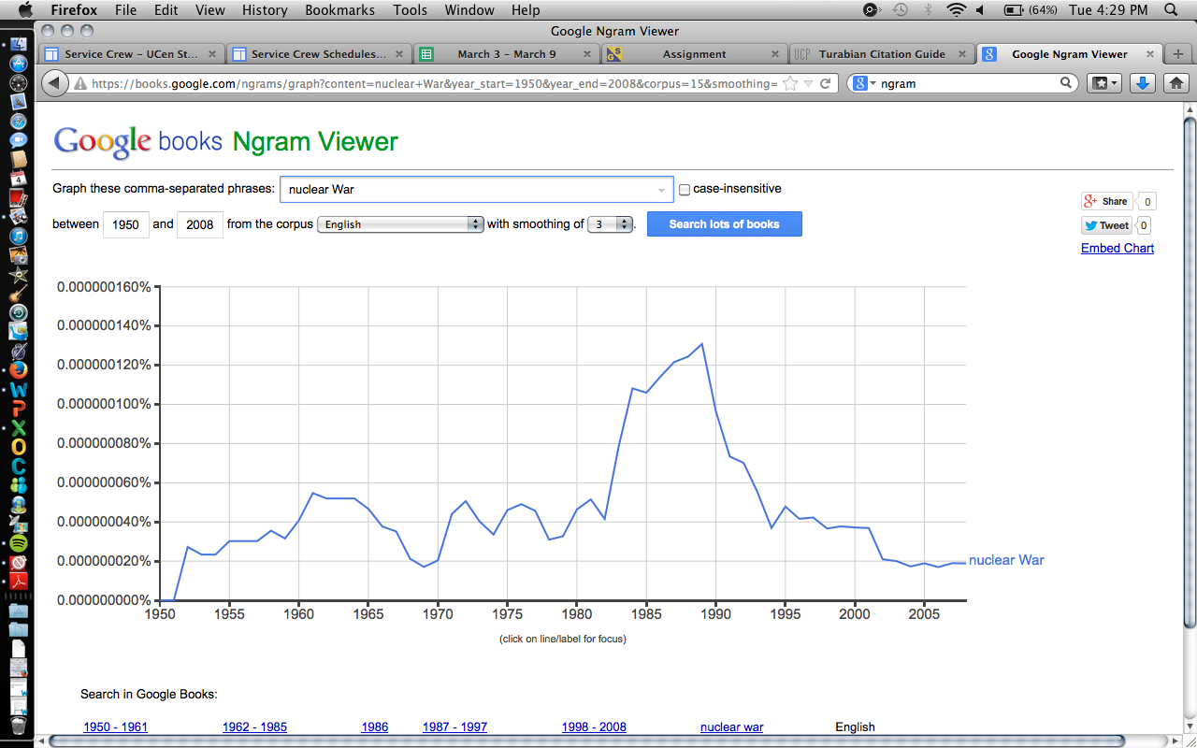
- Nuclear war experiences a slight increase after the Vienna Summit of 1961 and seen more around 1985. Here is the separate Ngram for the term “nuclear war”. The smaller scale allows us to see how much the use of the term changed over time. There are spikes and drops beginning after 1950. The two highest spikes are around 1961 and 1988. Once the idea of unification Germany after 1989 begins to gain more support, there is a drop in the use of the term “nuclear war” as the Soviet Union begins losing its hold on East Germany.

-German: Chruschtschow,Kennedy,Atomkrieg(Smoothing of 2)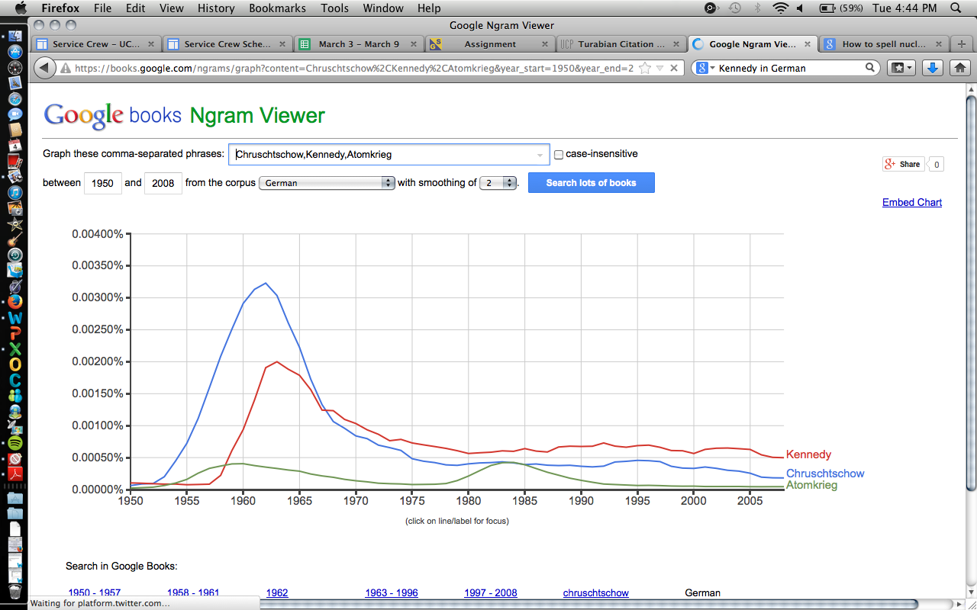

- For all three terms, there is a spike around 1961. Kennedy and Khrushchev start to drop off in German writing and publishing after that initial spike.
- Atomkrieg has another spike around the same time that the American English books see a spike, around 1988.
- At the end of the time frame used, Kennedy is discussed and/or published more in German books than the other two terms.

- Russian: Хрущев,Кеннеди(Khrushchev, Kennedy in Russian)-Smoothing of 2
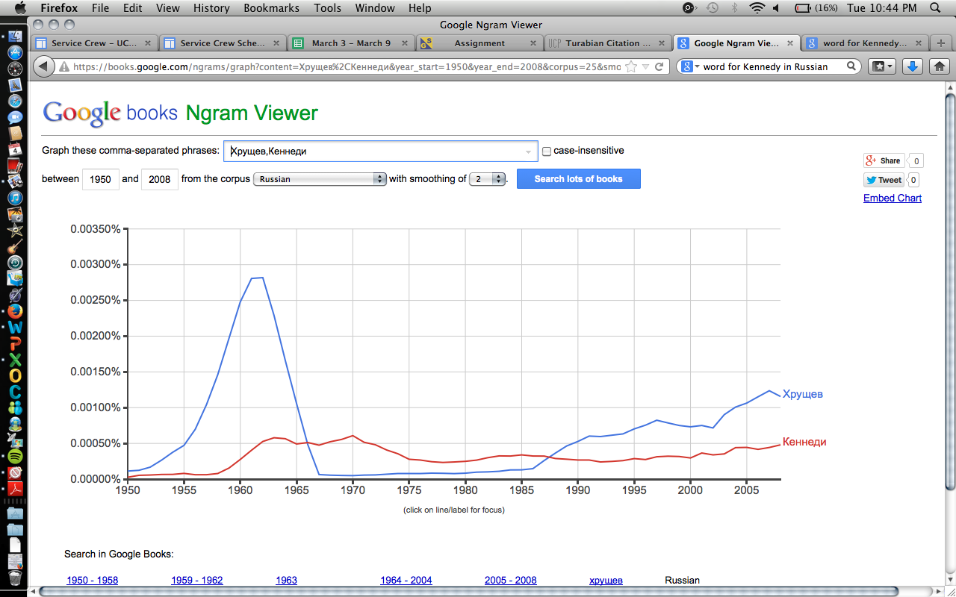
- There is a huge spike in how often Khrushchev is mentioned in Russian books around 1961. There is a spike for Kennedy as well but not as prominent.
- As tensions increased, Khrushchev was mentioned less than Kennedy (who was still mentioned very little.), but by the end of the time period Khrushchev starts coming up more in Russian books.
Term: ядерная война(nuclear war in Russian)- Smoothing of 2
- Nuclear war was not mentioned as much as Khrushchev and Kennedy so it had to be put on a separate Ngram.
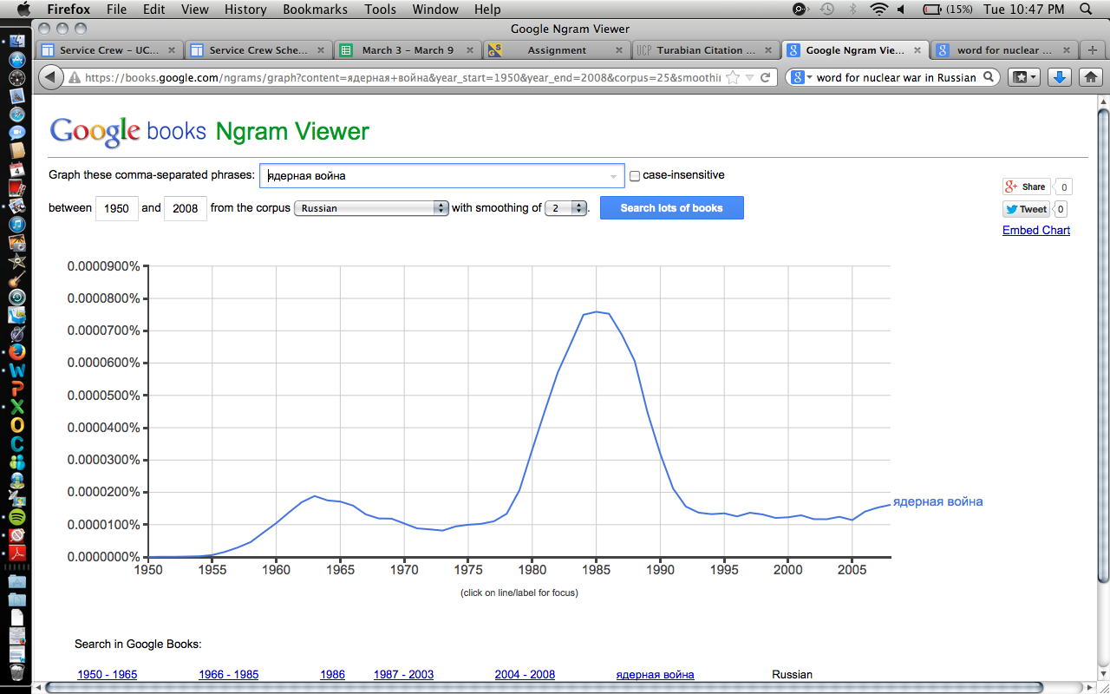

- It begins increasing after 1961 but there is a prominent spike during the mid to late 1980s. This is probably due to the increasing tensions during that time as both countries feared a nuclear war was imminent.

Bibliography
Bischof, Gunter, Stefan Kramer, and Barbara Staelzi-Marx. 2014. The Vienna Summit and its
importance in International History. Langham: Lexington Books.

Gaddis, John Lewis. We Now Know: Rethinking Cold War History. Oxford: Clarendon Press;
New York: Oxford University Press, 1997.

Kempe, Frederick. Berlin 1961: Kennedy, Khrushchev, and the most dangerous place on Earth.
New York: G.P. Putnam’s Sons, 2011.

