Elisabeth Ruemke
Professor Marcuse
UCSB History 133C Source Exploration Essay
June 12, 2019
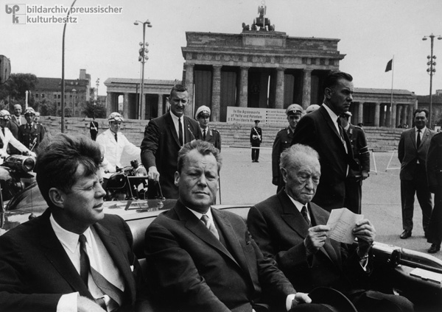
© Bildarchiv Preußischer Kulturbesitz / Will McBride
John F. Kennedy, Willy Brandt & Konrad Adenauer
Kennedy overwhelmed by West Berlin enthusiasm
Great turnout for American president’s speech in front of Schöneberg City Hall.
Abstract
American president John F. Kennedy visited West Berlin on June 26, 1963. He drove through the city and gave a speech in front of the Schöneberg City Hall. In this speech, he said the famous words: “Ich bin ein Berliner”. According to recent studies, this could be seen as a grammatical error, because with this sentence Kennedy actually said that he is a jelly doughnut. In this source exploration, we will see that the audience did not pay attention to the ‘error’. We will also see that the ‘error’ is not necessarily an error. By using the word ‘ein’, Kennedy affirmed that he is not officially a Berliner, but that he is Berliner-ish. In the biographies about Kennedy, the authors describe the overwhelming turnout for Kennedy and the enthusiasm the crowd was showing. The crowd felt the solidarity that Kennedy had for West Berlin. On the airplane, on his way to Ireland, Kennedy told his speechwriter, Torenson: ‘We’ll never have another day like this one as long as we live’, which shows all the feelings that Kennedy had from that day.
Source
John F. Kennedy’s speech in front of the Schöneberg City Hall in Berlin, June 26, 1963, in Public Papers of the Presidents of the United States. John F. Kennedy. Containing the Public Messages, Speeches, and Statements of the President. January 1 to November 22, 1963. Washington, DC: U.S. Government Printing Office, 1964, no. 269, pp. 524-25.
In this relatively short speech on June 26, 1963, in front of the Schöneberg City Hall in Berlin, US President John F. Kennedy talked about his view of Berlin and said the very famous sentence: “Ich bin ein Berliner”. He came to visit Berlin in the light of his foreign policy and the freedom that people seem to be looking for. He said that Berlin will only be free if it is an undivided city again. He mentioned that the Berlin Wall is a symbol of the failure of the Communist System. He called democracy an unperfect system but said that they had never been forced to be a wall up to keep people in the country. He spoke highly of West Berlin; that he never saw a city with so much hope, determination, vitality and force as West Berlin. Kennedy said that people were looking forward to the day that the city of Berlin would be reunited. He emphasized that West Berlin was still ‘free’, because they were not the side that put up the wall. He ended his speech with saying that as a free man he took pride in the words: ‘Ich bin ein Berliner.’ This was the second time that he mentioned that sentence.
The speech was very anticommunists and advisers of Kennedy told him after the speech that he might have been a bit too far. Kennedy seemed to be very affected by the Berlin Wall, that he had visited just moments before the famous speech and he felt that the audience would do anything that he told them to, something that fueled Kennedy’s anticommunist feelings. He wanted to make sure that people in East Berlin and the rest of East Germany would also hear his speech. The view from West Berlin to East Berlin had been blocked by red banners, so Kennedy could not see East Berlin and East Berliners could not see Kennedy. They had to hear the speech on the radio. The blockage of the view of East Berlin can be seen on the picture at the beginning of this source exploration. The drapes are placed in front of Brandenburg Gate.
The tour through Germany was four days out of his entire Europe visit. The speech in Berlin was part of the last place he visited before going to Ireland. On the morning of June 26, he flew to Tegel Airport and made a tour through the entire city before giving the speech. He made six stops, the speech he gave in front of City Hall was part of the fourth stop.
In this source exploration, we will see what people expected before he gave the speech and in what way the speech was received in Germany and the rest of the world, mostly the United States. This study is based on newspaper articles, articles about the speech and biographies about Kennedy. What will be see is that the newspapers that were published just after the speech do not mention the alleged grammatical error that Kennedy made. We will see that they mostly talk about the cheering of the audience and the warm welcome that Kennedy received in Berlin during his day there.
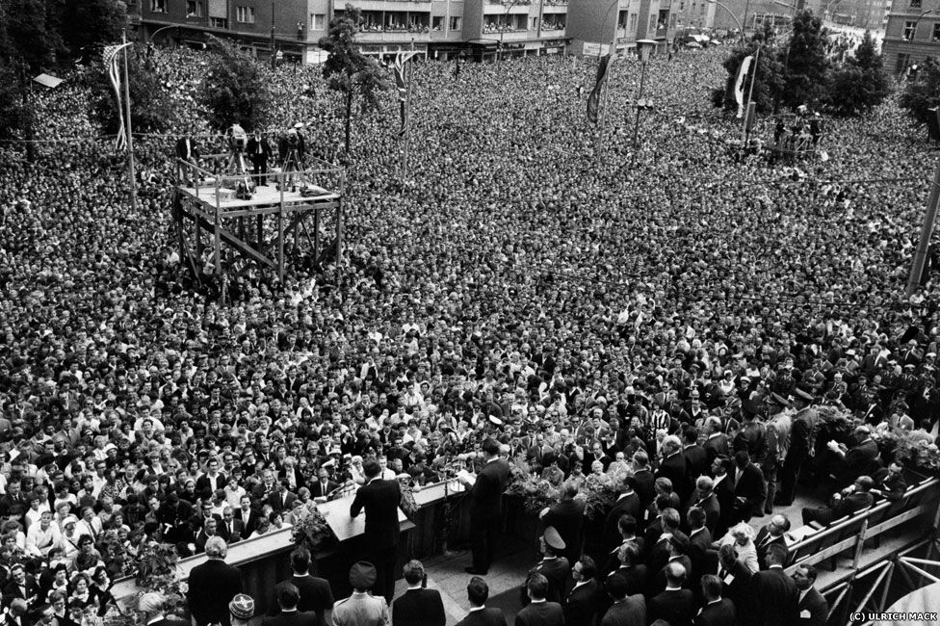© BBC News, Berlin, June 26, 1963
Annotated Bibliography in Chronological Order
‘Kennedy in Deutschland: Bonn/Kennedy Besuch’. Der Spiegel, Hamburg, Germany, June 26, 1963, Vol 26.
https://www.spiegel.de/spiegel/print/index-1963-26.html
This article dated on the day that Kennedy gave the famous speech touches upon some important events and relationships in Europe during Kennedy’s presidency. It starts by saying that Kennedy did not like Germans, but that he is still making his way to the European country. He actually wanted an alliance with France and England, in that way he wanted to put Germany on the sideline. He said that he wanted to avoid a new world war that could start in Germany. The middle part of the article is about the upbringing of Kennedy, how he was raised and why there was no room for Germans in his upbringing. The article ends with that Kennedy probably wanted to talk about the American economy, while the German government wants to talk about his vision in his ‘strategy of peace’ and how far the United States was willing to go to reach reunification, because Adenauer called it a nightmare if the East and the West reunite at the cost of the Germans.
‘President Hailed by over a Million in Visit to Berlin’. New York Times, New York, New York, June 27, 1963.
https://timesmachine.nytimes.com/timesmachine/1963/06/27/82069980.html?action=click&contentCollection=Archives&module=LedeAsset&region=ArchiveBody&pgtype=article&pageNumber=1
The article in the New York Times is very positive about Kennedy’s visit in Berlin. This could be because it is an American newspaper, but the New York Times has been a reliable source for many decades, so we can say that a big part of the article will be based on the truth. The article mentions that the speech was an ‘emotional high point of a spectacular welcome accorded the President by West Berlin’. It also mentions the chanting of the people during his speech, screaming ‘Kennedy, Kennedy’. The article does refer to the famous sentence, but it does not mention that the use of ‘ein’ in this sentence could be seen as a grammatical error.
‘Kennedy Scores’. The Christian Science Monitor, Boston, Massachusetts, June 27, 1963:1.
https://search.proquest.com/hnpchristiansciencemonitor/docview/510509378/pageviewPDF/5F1F5389057242E7PQ/1?accountid=14522
The title of this newspaper article is ‘Kennedy Scores’, which indicates that the speech that Kennedy gave was a big success. One of the subtitles in this article is ‘Spontaneous Welcome’, which indicates that Kennedy was not expecting the big welcome that he received in Berlin. This is underlined by the following quote: ‘not even Hitler with his famous parades, had brought out the people the way the American President did. The screaming, cheering, flag-waving, confetti-tossing welcome exceeded the mammoth reception West-German crowds gave Mr. Kennedy earlier this week’.
J. Emlyn Williams. ‘Kennedy’s Berlin Triumph’. The Christian Science Monitor, Boston, Massachusetts, June 28, 1963:2. https://search.proquest.com/hnpchristiansciencemonitor/docview/510496769/A7B7D6A6600449F6PQ/1?accountid=14522
The title of this newspaper article indicates that his visit in Berlin was successful. The article emphasizes that the positive reception of Kennedy’s visit was a surprise, even for people who were very optimistic about the President. More than a million people came out during June 26 to see the President travel through the city. This was supposed to be nearly half of the population of West Berlin. This city had almost never experienced such a jubilee. Every line of his speech was received with a big cheer from the crowd.
‘Deutsches Votum für Kennedy’. Die Zeit, Hamburg, Germany, June 28, 1963. https://www.zeit.de/1963/26/deutsches-votum-fuer-kennedy
The title of the article is: The Germans vote for Kennedy. How he came, spoke and convinced. This is a reference to Caesar’s quote ‘veni, vidi, vici’, but can also be a reference to the first section of Kennedy’s speech: “Two thousand years ago—two thousand years ago, the proudest boast was ‘civis Romanus sum’.” Caesar was a very powerful leader, so perhaps people saw Kennedy as a powerful leader as well. The line ‘came, spoke and convinced’ indicates that what Kennedy said was believed by the people.
Theodore Sorensen. Kennedy. New York: Harper & Row, 1965.
Ted Sorensen, the speechwriter of John F. Kennedy, only mentions the speech very briefly in his biography about Kennedy. He mentions that he remembers people chanting ‘Kenne-dy, Kenne-dy’ and that the speech was one of the most inspired and inspiring speeches he ever gave. The number of people, their chanting and their eyes full of hope and gratitude was something very emotional to Sorensen and other members of the Presidential party. He recalls that Kennedy was glowing in the airplane from Germany to Ireland and that he felt that he had a better understanding of the necessity of reunification of Berlin and Germany.
Jürgen Eichhoff. ‘"Ich bin ein Berliner": A History and a Linguistic Clarification’, Monatshefte, Vol. 85, No. 1 (Spring, 1993), pp. 71-80.
Eichhoff wrote an article about the history and the linguistic clarification of the famous speech and the famous sentence of Kennedy. He breaks down the speech of Kennedy and mentions the moments when the President received big applause, at the end of the two times that he said ‘Ich bin ein Berliner.’ Eichhoff says that unlike New York Times reported, the audience seemed to perfectly understand what Kennedy wanted to tell them. Kennedy apparently neglected the speech that was prepared for him and he added the famous sentence just a few moments before he gave the actual speech.
Robert Dallek. An Unfinished Life: John F. Kennedy, 1917-1963. Boston: Little, Brown, and Co, 2003.
Robert Dallek, an American historian, has clearly also read the biography by Theodore Sorenson and repeats the chanting and cheering of the crowd. He compares the reception of the speech with the ‘communal outbursts at Nazi rallies.’ Dallek does talk about the use of ‘ein’ in the famous sentence. He said that in the enthusiasm of the audience, nobody complained that Kennedy should have said ‘Ich bin Berliner’ instead of ‘Ich bin ein Berliner’ and that everybody cheered as an approval of what Kennedy said.
Andreas W. Daum. Kennedy in Berlin. Washington, D.C.: German Historical Institute; New York: Cambrigde University Press, 2008. (First published in German by Verlag Ferdinand Schöningh 2003).
Daum, a German historian who currently works at the State University of New York at Buffalo, mentions how cheerful the crowd was when Kennedy gave his speech. In front of approximately 450,000 people, Kennedy said the famous words and people kept cheering, something that they had been doing the entire time they were on the square in front of the City Hall. Daum mentions that the New York Times has written articles about how people giggled when Kennedy said the famous, wrong, sentence. There seems to be no proof that the people of the audience had a smile on their face during the error, but what we do know is that people cheered: there was merely enthusiasm for Kennedy and people did not see the error as a reason to laugh.
Robert G Waite. ‘‘Ish bin ein Bearleener’ – JFK’s 26 June 1963 Visit to Berlin: The Views from East Germany’, Journal of Contemporary History, 2010, Vol. 45(4), pp. 844-865.
Historian Waite presents the way that Kennedy was received and how he interpreted his own presence in West Berlin and the speech he gave. He was surprised by the number of people who were standing on the side lines while he travelled through Berlin. These people were all chanting for him. On the airplane, flying to Ireland, Kennedy told Sorenson: ‘We’ll never have another day like this one as long as we live,’ which shows the impact the day in Berlin had on Kennedy. What is remarkable in this article, is that Waite mentions that Adenauer was too close to the negotiations for a reunified Germany and that the major powers wanted to avoid that topic during his visit in Berlin. This is the complete opposite of what we have seen in Der Spiegel (first article in this source exploration). Reactions in East Berlin to his speech were all quite similar: a journalist said on the radio that Kennedy’s speech was a ‘warlike tirade’ and the chairman of the East Berlin SED said that the visit had not changed anything for the city. It only verified the shortcomings of the Western power. Kennedy’s visit sparked a new discussion in German papers about the racial American South and that the President should focus to ‘bring an end to the mistreatment of Negroes’. Nonetheless, Kennedy called this visit ‘the most overwhelming reception of his career’.
Waite used the following sources: Washington Post, Der Tagesspiegel and several other German newspapers, New York Times, biography of Sorenson, the articles of Daum, Eichhof and (East) German magazines. All are very similar or even the same in this source exploration.

So, as Daniel Chong explained in his source exploration, the sentence of Kennedy is not actually a grammatical error. As he found in an article were the link does not exist from anymore, it is common in German to say ‘ein’ when you are not really serious about that you are something. He explains it with the example: ‘Ich bin Clown’, which means that you are actually a clown. If you would say: ‘Ich bin ein Clown’, you actually say that you are acting ‘clownish’. So, in the case of Kennedy, the use of ‘ein’ works, because he is technically not from Berlin. It was only years later that people started to call it a grammatical error.
I did some research to find the article of the New York Times that reported that the audience did not seem to understand what Kennedy meant. I could only find the articles where they say the opposite and Eichhoff is not giving a reference for this information. Even though it is hard to verify this part of Eichhoff’s article, I do find it an interesting contrast to the rest of what I have found.

