Rock Beats Bricks

Exploration: An East German Rock ‘n’ Roll Riot at the Wall Turns Political (June 10, 1987)
Robert J. McCartney, “East German Police, Rock Fans Clash in Berlin for the Third Straight
Night,” International Herald Tribune, June 10, 1987.
http://germanhistorydocs.ghi-dc.org/docpage.cfm?docpage_id=1919

On June 10, 1987, Robert J. McCartney wrote an article on the Concert for Berlin and published it in the International Herald Tribune. Through his writings, he states that the musical performances helped change East Berliner’s views on the Berlin Wall. Organizers of the event in West Berlin strategically placed the stage and loudspeakers so that the music could be amplified to East Berlin. The music provoked an uproar and sparked a riot among East Berlin youth. The change in the mindset of the wall and the physical resistance of the youth ultimately resulted in the fall of the Wall. In 1987, Berlin reached the respectable age of 750 years, and the city, although still torn in two by the Wall, decided to celebrate this symbolic event. East Germany sought to use this anniversary of Berlin to highlight its successes in its standards of living. The celebration included the Concert for Berlin, a three-day music festival which featured David Bowie, Eurythmics, and Genesis. The concert took place six days before Ronald Reagan’s visit to West Berlin where he delivered his powerful speech asking Gorbachev to tear down the Wall. Can rock music break bricks? It’s certainly not underestimated after observing the events at this concert.

The Concert for Berlin was a three-day open-air music festival held from 6 to 8 June on the Platz der Republik. The stage was a stone-throw away from the Berlin Wall, directly on the Western side of the Brandenburg Gate where president Reagan was going to speak. The gigantic stage was backed up so that the Berlin Wall acted as a backdrop. An extra-large poster that featured David Bowie, Genesis, and Eurythmics attracted a large crowd of Berliners, as well as the low rate to attend the entire festival costing only 50 marks. The organizers in West Berlin turned some loudspeakers towards the Wall so that the music could be audible to East Berliners. The positioning of the speakers was intentional so that the music would amplify loud enough to the other side of the Wall and question its existence. About 3,000 young people gathered around the stage and along the Wall to listen to the music.
David Bowie, a leading musician in the rock industry, played on June 6th, the first day of the festival. He lived in West Berlin for three years in the late 1970s and was heavily influenced by the city's expressionism and pop art. He performed as part of the Glass Spider Tour and played a total of 26 songs. His song “Heroes” was the most influential, as many people living in both East and West Berlin could relate to it. The song “Heroes” captures the hopelessness and desperation of a city divided, friends and family in the East kept apart from their loved ones in the West by violence and terror. As seen in the lyrics:
I, I can remember (I remember)
Standing, by the wall (by the wall)
And the guns, shot above our heads (over our heads)
It further tells the story of two lovers, Henri Weise, and a German woman, who meet at the Wall and try, hopelessly, to find a way to be together. Their story is told through the following lyrics:
And we kissed, as though nothing could fall (nothing could fall)
And the shame, was on the other side.
The song ends with the hope that things will change, if only for a day:
We're nothing, and nothing will help us
Maybe we're lying, then you better not stay
But we could be safer, just for one day.
Bowie describes that this was one of the most emotional performances he ever did, and that playing Heroes felt like an anthem and a prayer. Thousands of East Berliners came close to the Wall to cheer and sing along to the song. David Bowie acknowledged them by saying to them in German, “the band sends our best wishes to all of our friends who are on the other side of the Wall.”
The Eurythmics were a pop-rock British music duo from London. They played on June 7th, the second day of the concert. About 3,000 East Germans gathered near the Berlin Wall to hear the music. As they approached the Wall, police put up a four-foot-high fence about 220 yards in front of the Brandenburg Gate in an attempt to stop them. Some of the Berliners managed to break through the fence. The police reacted violently by beating and dragging the East Germans by their hands and feet. The angry youth responded by throwing stones and bottles at the police while chanting, “The Wall must go! and Gorbachev! Gorbachev!” East German Police arrested at least 60 East Berliners that night. This was the start of the riots at the Wall.
Genesis was a rock band that performed on June 8th, the final day of the concert. By the third day, 2,000 East Berliners headed to the Wall to listen to Genesis play. The East German police decided that they had enough. They began to violently attack people with water cannons and arrested about 200 East Berliners.
The location of the concert and its heavy publicity accounted for the large number of East Berliners who tried to listen to the music on the opposite side of the Wall. The organizers of the event could have chosen any other location to hold the concert. Instead, it was held near enough to the border that many East Berliners crowded along the Wall to listen to the rock music wafting across the city. Although police tried to stop East Berliners from getting to close to the Wall, they could not stop the radio-waves that helped increase the number of people who showed up. The West German-operated, US-run radio station, Radio in the American Sector (RIAS), convinced the musicians to allow the shows to be simulcast to all parts of the divided city. Securing permission was rare because broadcasting the concert was believed to undercut album sales due to the possibility of home taping. The West was very aware that the musicians’ lyrics would provoke an uproar at the Wall. To convince the musicians, RIAS argued of how hungry East German kids were for popular music from their capitalist “enemies,” the record label companies.
Rock music was treated as a destabilizing threat and was considered the forbidden fruit of Berlin. The communist party leadership of the GDR had always feared that rock music would incite the country's entertainment-starved youth to rebel. Although the GDR had this suspicion, no attempt to cancel or postpone the concert was made. The police’s attempt to hold off the youth was an attempt to keep East Berliners away from a corrupt influence. It is reasonable to assume that the concert was a conscious act of provocation, especially because the West was very aware of how hungry East German kids were for popular music from their capitalist "enemies." In the wake of the concert, the GDR realized it had made a mistake.
The Berlin Wall came down two years after the concert was played. Reagan’s speech, along with the Concert for Berlin a week earlier, had helped change the mood around the Wall. The musicians’ political messages communicated through their songs helped spark a change for the view of the Wall. The third night of the concert turned the gathering of people who wanted to listen to the music into a political act after they reacted violently. Olof Pock, a 15-year-old kid living in East Berlin at the time, said that “the concert was somehow being done for East Germany’s youth’s benefit. The mood was one of enjoying the forbidden fruit.”
Often, rock music is characterized by stereotypes such that the lyrics have no meaning. The performances by David Bowie, The Eurythmics, and Genesis played a role in the fall of the Berlin Wall. Their lyrics’ political messages changed the ideology of youth who had not questioned the existence of the Berlin Wall before. The change in ideology could not have been achieved without the widespread advertising of the music through the venue’s location and the radio. Through their music, they realized their oppression and division brought on by the Berlin Wall. The Berlin youth’s resistance proved that rock music was stronger than the bricks dividing them. The Wall had to go!
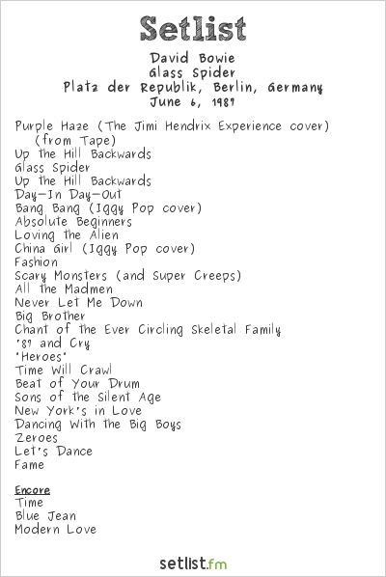
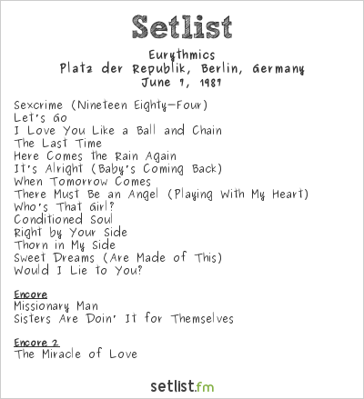

Eurythmics Concert Setlist
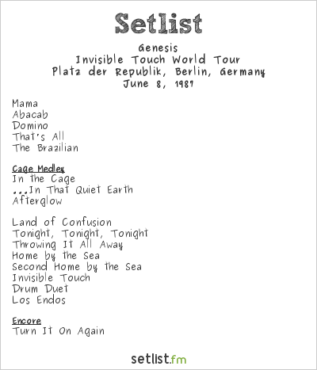
Genesis Concert Setlist

David Bowie Concert Setlist
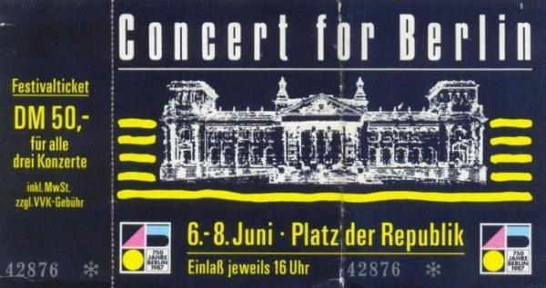

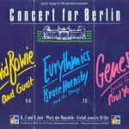

Concert for Berlin Ticket

Concert for Berlin festival Poster

Annotated Bibliography in Chronological Order

“Rock Music at Berlin Wall Sparks Riot by E. Germans.” Los Angeles
Times/Associated Press. June 8, 1987.
https://www.latimes.com/archives/la-xpm-1987-06-08-mn-477-story.html.
Accessed June 6, 2019.
This article contains information on the protests that rose between youth and law
enforcement at the Wall. It is important to touch upon why these riots were
manifesting and what was causing them. These riots caused a political mindset in
the youth who then questioned the existence of the Wall.

McCartney, Robert J. Washington Post Foreign Service. "East German Rock Fans, Police
Clash; Youths Try to Hear Genesis Concert on the Other Side of Berlin Wall". The
Washington Post. June 9, 1987, Tuesday, Final Edition.
https://advance.lexis.com/api/document?collection=news&id=urn:contentItem:3S8G
P8J0-000B-1093-00000-00&context=1516831.
This article includes information on the importance of the location of the stage the musicians performed on. It talks about the specific positioning of the loudspeakers which allowed the music to be amplified form West Berlin over the Wall into East Berlin. This information is useful when arguing that the concert was intentionally used to cause an uproar that led to the fall of the Berlin Wall.

McCartney, Robert J. “East German Police, Rock Fans Clash in Berlin for the Third
Straight Night,” International Herald Tribune, June 10, 1987.
http://germanhistorydocs.ghi-dc.org/docpage.cfm?docpage_id=1919
The GHDI source contains a document of the events recorded at the Berlin Wall in 1987 during a rock-n-roll riot. The description of the document is: When the rhythms of Western rock groups like Genesis and David Bowie floated across the Wall, they sparked rock riots on the Eastern side. Angry fans scuffled with the people’s police [Volkspolizei] and called for Gorbachev-like reforms and an opening of the border.
McCartney, Robert J. Washington Post Foreign Service. "Gorbachev Seen as Factor In
Rock Clash; E. German Public May Want Reforms". The Washington Post. June
10, 1987, Wednesday, Final Edition.
https://advance.lexis.com/api/document?collection=news&id=urn:contentItem:3
8G-P8F0-000B-105B-00000-00&context=1516831.
This article talks about how East Berliners rioted as a responded to East Berlin
police using violence against them.

Deutsche Welle. "'87 Concert Was a Genesis of East German Rebellion.” April 07, 2007.
https://www.dw.com/en/87-concert-was-a-genesis-of-east-german-rebellion/a-26
3850. Accessed May 02, 2019.
This article gives perspective to how both bands Genesis and Eurythmics reacted to the protest and on their impact that ultimately led to the fall of the Berlin Wall. It also gives an interesting perspective on how the concert was widely advertised as the “forbidden fruit to East Berlin.” It also explores the intentions of the concert and answers questions such as: was the concert purposely put up to provoke a riot, where the artists’ musical message intentional, and was there intention in amplifying the music to East Berlin?

Provençal, Jérôme. “6 Juin 1987: Concert for Berlin.” Notes de Passage. March 24, 2015.
https://philharmoniedeparis.fr/fr/magazine/6-juin-1987-concert-berlin Accessed
June 5, 2019.
The title of this website translates to “Passing Notes,” a magazine by the Cité de la musique-Philharmonie de Paris. It talks about the reasons for the celebration of the concert. It also talks about the significance of the set-up of the venue and touches on Davis Bowie’s experiences at the concert.

Fisher, Max. "David Bowie at the Berlin Wall: The Incredible Story of a Concert and Its
Role in History." Vox. January 11, 2016. https://www.vox.com/2016/1/11/10749546/david-bowie-berlin-wall-heroes. Accessed May 02, 2019.
This article talks about David Bowie’s experience at the rock festival. It also touches on his personal life growing up in Germany and how his experiences and observations of the Berlin Wall influenced his music creation, such as in his song “Heroes” The source is backed up by Rolling Stone magazine which touches on Bowie’s musical influence that led to the fall of the Berlin Wall.

Calamur, Krishnadev. “Heroes at the Wall.” The Atlantic/Reporter’s Notebook. January
11, 2016. https://www.theatlantic.com/notes/2016/01/bowie-berlin-1987/423564/.
Accessed June 6, 2019.
This magazine touches on the impact David Bowie had on the fall of the Wall on behalf of his performance. Bowie performed an emotionally filled concert day one of the festival. The article explains the meaning of his song “Heroes” and it’s how it became an anthem to East Berliners.

Tofani, Felipe. “David Bowie Berlin Concert 1987: The Glass Spider Tour in front of the
Reichstag.”March28,2017.
https://fotostrasse.com/david-bowie-berlin-concert-1987/. Accessed June 6, 2019.
This article gives an overview of the Berlin Concert. It talks about David Bowie’s
performance, the location of the stage in respect to the Berlin Wall, and how the
concert was advertised through the radio.

Grossman, Victor. A Socialist Defector: From Harvard to Karl-Marx-Allee. New York:
Monthly Review Press, 2019, Page 130-131.
Victor Grossman includes a section on the 1987 concert in his book, A Socialist Defector. He thinks the concert was intended to provoke East German authorities by drawing young East Germans to the Wall.

"Concert for Berlin 1987 Setlists." Setlist.fm.
https://www.setlist.fm/festival/1987/concert-for-berlin-1987-1bd7a9ec.html.
Accessed June 06, 2019.
Setlist.fm is a website that collects setlists, a document that lists the songs that a
band or music artist plays during a concert, posters that advertise the music artists
who are to perform, and the tickets that were sold to attend the concert. The
website features a variety of music genres, artists, festivals and venues.

Provençal, Jérôme. “6 Juin 1987: Concert for Berlin.” Notes de Passage. March 24, 2015. https://philharmoniedeparis.fr/fr/magazine/6-juin-1987-concert-berlin Accessed June 5, 2019.
Robert J. McCartney, “East German Police, Rock Fans Clash in Berlin for the Third Straight Night,” International Herald Tribune, June 10, 1987. http://germanhistorydocs.ghi-dc.org/docpage.cfm?docpage_id=1919
Provençal 2015.
Grossman, Victor. A Socialist Defector: From Harvard to Karl-Marx-Allee. New York: Monthly Review Press, 2019, Page 130-131.
Calamur, Krishnadev. “Heroes at the Wall.” The Atlantic/Reporter’s Notebook. January 11, 2016. https://www.theatlantic.com/notes/2016/01/bowie-berlin-1987/423564/. Accessed June 6, 2019.
Provençal 2015.
McCartney, Robert J. Washington Post Foreign Service. "East German Rock Fans, Police Clash; Youths Try to Hear Genesis Concert on Other Side of Berlin Wall". The Washington Post. June 9, 1987, Tuesday, Final Edition. https://advance.lexis.com/api/document?collection=news&id=urn:contentItem:3S8G-P8J0-000B- 093-00000-00&context=1516831.
Tofani, Felipe. “David Bowie Berlin Concert 1987: The Glass Spider Tour in front of the Reichstag.” March 28, 2017. https://fotostrasse.com/david-bowie-berlin-concert-1987/. Accessed June 6, 2019.
Tofani 2017.
Fisher, Max. "David Bowie at the Berlin Wall: The Incredible Story of a Concert and Its Role in History." Vox. January 11, 2016. https://www.vox.com/2016/1/11/10749546/david-bowie-berlin-wall-heroes. Accessed May 02, 2019.
Provençal 2015.
Provençal 2015.
Fisher 2016.
Fisher 2016.
Fisher 2016.
Fisher 2016.
Fisher 2016.
Tofani 2017.
Tofani 2017.
“Rock Music at Berlin Wall Sparks Riot by E. Germans.” Los Angeles Times/Associated Press. June 8, 1987. https://www.latimes.com/archives/la-xpm-1987-06-08-mn-477-story.html. Accessed June 6, 2019.
“Rock Music at Berlin Wall Sparks Riot by E. Germans.” Los Angeles Times/Associated Press.
McCartney, Robert J. Washington Post Foreign Service. "Gorbachev Seen as Factor In Rock Clash; E. German Public May Want Reforms". The Washington Post. June 10, 1987, Wednesday, Final Edition. https://advance.lexis.com/api/document?collection=news&id=urn:contentItem:3 8G-P8F0-000B-105B-00000-00&context=1516831.
Deutsche Welle. "'87 Concert Was a Genesis of East German Rebellion.” April 07, 2007. https://www.dw.com/en/87-concert-was-a-genesis-of-east-german-rebellion/a-26 3850. Accessed May 02, 2019.
Fisher 2016.
Fisher 2016.
Deutsche 2007.
Deutsche 2007.
Fisher 2016.
Deutsche 2007.
Deutsche 2007.
Deutsche 2007.
Fisher 2016.
Fisher 2016.
Fisher 2016.

