**A Call for Warfare:   
Contemporary Responses to the Publication of the Zimmermann Telegram**

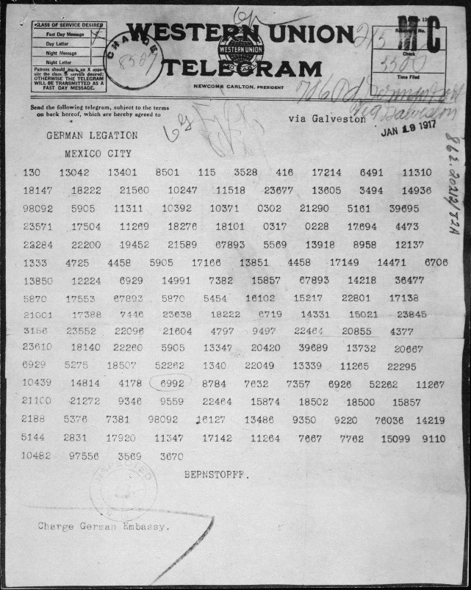Biography:

Arthur Zimmermann was born in East Prussian Marggrabowa (present-day Olecko in northeastern Poland) in 1864 and died in 1940 in Berlin, Germany. He studied law and entered the diplomatic service. He was posted to China in 1896, where he witnessed the Boxer Rebellion. Zimmermann returned to Germany in 1916, where he became Secretary of State (Foreign Minister) during WWI. The Zimmermann Telegram, named after him, was written to solve the issue of the United States joining the war after Germany began unrestricted submarine warfare.[1]

Overview:

As the war in Europe continued to worry the US public in 1917, President Wilson refused to enter it to maintain his promise of keeping the US out of war and being neutral. While many factors played a role in the breaking of this promise, the Zimmermann Telegram was a factor that helped move forward the decision to start the war. The Zimmermann Telegram is a document created with the purpose to ask help from Mexico during WWI. When the war started Britain made a move to destroy any trans-Atlantic connection that Germany had, forcing the German government to send the telegram through a private diplomatic cable from Berlin, which led to it being intercepted by a group of spies and codebreakers of the British Intelligence department called Room 40 Codebreakers.[2] The Zimmermann Telegram was written on January 13 and sent on January 19, and it was intercepted and deciphered not long after. The telegram had two parts, the first part was to inform Bernstorff, the German Ambassador to the United States, of the Germany's plan to restart unrestricted submarine warfare on February 1. The second part was to be sent to Heinrich von Eckardt, the German Ambassador to Mexico, to make an offer to Mexico about making an alliance with Germany in exchange for territories that were lost during the Mexican War in 1848.[3] The agreement that was proposed included that Germany would help Mexico regain territories in the US (New Mexico, Texas, and Arizona) in exchange for keeping the US in check and convincing the Japanese government to join in their alliance.

Having learned about the plans of Germany, the British intelligence department pondered over sending the telegram to the US government as it could uncover how they were intercepting documents from other countries. It wasn’t until February 24 that British Ambassador Page sent a telegram to US Secretary of State Lansing with a translation of the Zimmerman telegram and about how the British government wished to keep secret their involvement in the deciphering of the telegram, but that they were in favor of it being published. Having learned about the telegram, Acting Secretary of State Fletcher sent a message to the US Ambassador in Mexico asking them to make a declaration. This can be interpreted as a tactic to amend the damages that the reputation of the Mexican government would take the moment the telegram would go public. Nevertheless, the president of Mexico, Carranza, refused to make a statement.

On March 1, 1917, US newspapers published their first articles relating to the Zimmermann Telegram, one day after Lansing had informed Ambassador Page that it would go public. During this period the telegram gained many names, in different telegrams it was called Zimmermann Note or the German Note, this is mostly related to the fact that such communications were called Diplomatic Notes as they came from diplomatic cables. This address can be observed in the Ngrams and how in the specific date of 1917 the phrase German Note took a sharp rise.

After the publication of the telegram there were different responses to it. Based on newspaper reports many members of the US-American public, which had been cultivating a dislike towards the German government since the submarine warfare started in 1915, were angry and wanted the US to join the war. Similarly, because of conflicts with Mexico, there was a growing anti-Mexican sentiment that intensified after the apparent alliance between Germany and Mexico. German American newspapers wanted to deny the accusations of treason and a plot against the government, saying that the telegram was a fabrication.[4] Mexican politicians also denied having heard anything about the telegram.[5] Similarly, the Japanese Ambassador denied having any involvement or having been reached by Mexico, saying that there were no offers made to them and that Japan would never accept an alliance with Germany.[6]

Internally in the US there were also conflicts regarding the telegram, mostly related to the authenticity of it. Members of Congress were suspicious of the legitimacy of the telegram, leading Lansing to ask Ambassador Page to ask the British government if the US could allow someone in their embassy to decode the telegram themselves to assure of the legitimacy of the decoded version.[7] These concerns about legitimacy could have come from the fact that the relationship of the US and Germany was already severed since Germany started attacking US merchant ships, and the recent unrestricted submarine warfare. While not completely clear on who was being blamed as a possible forger by the Congressmen, it can be inferred that it could be Mexico based on the previous conflicts that the nations had between each other during Pancho Villa’s revolution. And the other country could be Britain itself as it could be interpreted as wanting to bring the US into the conflict. However, on March 3, Zimmermann gave a press conference in Berlin, where he declared that the telegram was legitimate but that it wasn’t a plot against the United States but more of a measure.[8] While the Germans knew of the legitimacy of the telegram, there was mystery in how it was obtained. The press announced some theories that circulated regarding how it was found. The University Press cited an anonymous source that told them about how the telegram was found by 4 men of the First Indiana Infantry in the body of a man sent by the ex-Minister Bernstorff from Mexico.[9] At first this theory was believed to be true, as the British government didn’t want to have its involvement made public.

On March 29, Zimmermann gave another speech to the Reichstag to address the issue of the Telegram. In this speech he once again confirmed the legitimacy of the Telegram but questioned the means that the US government used to obtain the telegram.[10]

Along with publishing the telegram, newspapers encouraged the public to protest the neutrality that President Wilson wanted. The unrestricted submarine warfare had already stirred up the emotions of the US public, and the press used this issue to push towards the end of neutrality. Finally, on April 2, President Wilson held a press conference where he cited “unhappy events” that happened before his address, mainly referring to the unrestricted submarine warfare declaration and the Zimmermann Telegram.[11] The Zimmermann Telegram was regarded as evidence of the presence of spies in the government and as a sign of wanting to destroy the neutrality of the US. This led Wilson to abandon the neutrality promise and for the US to declare war on April 6 against Germany and its allies.

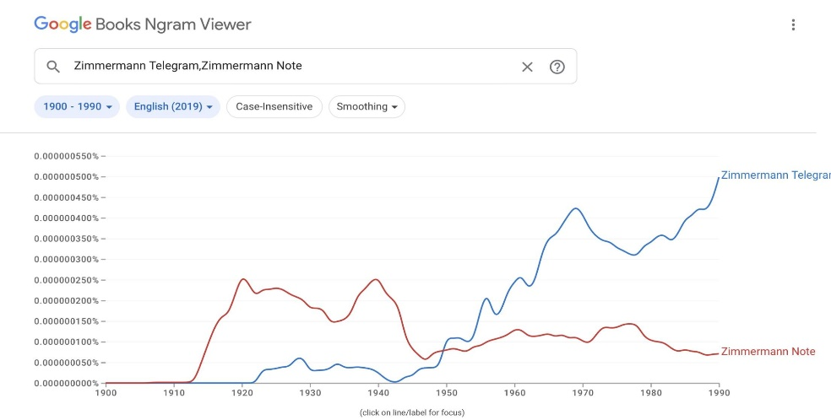

N-Grams:

Ngram:   
Zimmermann Telegram, Zimmermann Note   
(smoothing=3)

In these ngrams we can see how the term Zimmermann Telegram started to take more presence around 1951. This may be due to the rise of telephone communications, so that the word telegram was necessary to specify how the note was sent. The term Zimmermann Note was used during the 1920s more, as diplomatic communications were called “Diplomatic Notes.”

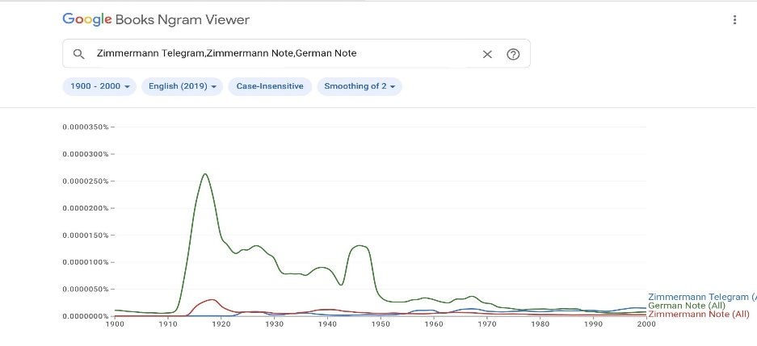  
  
Ngram:   
Zimmermann Telegram, Zimmermann Note, German Note  
(1900-2000)

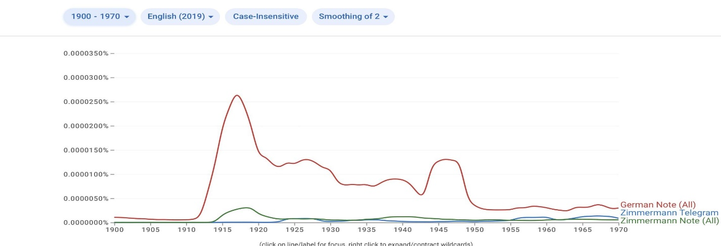The term German Note peaked in 1917, while both German Note and Zimmermann Note were eventually replaced by the term Zimmermann Telegram by 1986. This can be seen clearly in the following Ngrams. The peaks in "German Note" after the 1930s, especially in the late 1940s and 1950s, and around 1968 are probably related to diplomatic notes between West and East Germany (tensions before the building of the Berlin Wall in 1961, and preceding Chancellor Brandt's *Ostpolitik* in 1970), not to this document.

Ngram: Zimmermann Telegram, Zimmermann Note, German Note (1900-1970)

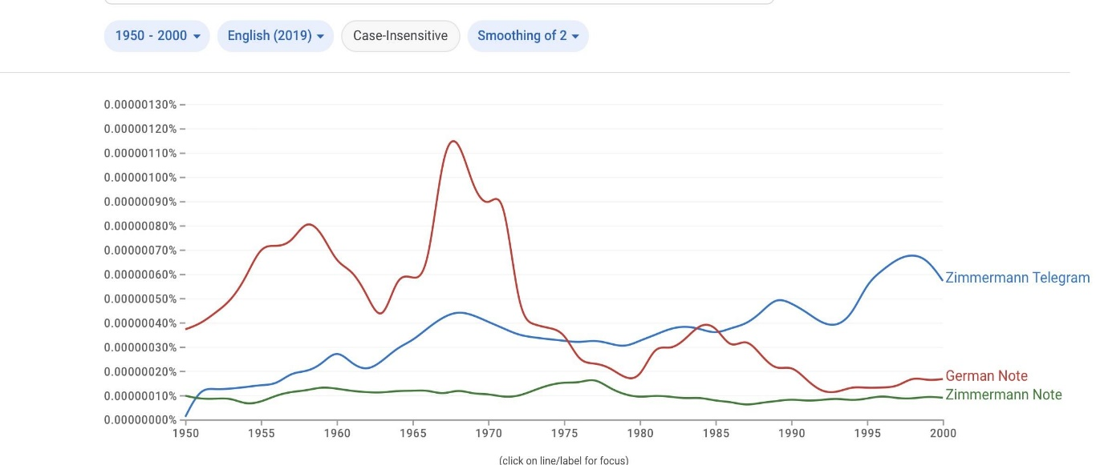

Ngram: Zimmermann Telegram, Zimmermann Note, German Note (1970-2000)

**Annotated Bibliography in Chronological Order:**

*Note:* Foreign Relations *has been ordered based on the publication of the Washington Printing Office, therefore the dates of the documents are ordered after the publication of newspapers and journal articles done before 1931.*

"WASHINGTON EXPOSES PLOT: OUR GOVERNMENT HAS ZIMMERMANN'S NOTE OF JAN. 19. BIG PROMISES TO MEXICO CONQUEST OF TEXAS, NEW MEXICO, AND ARIZONA HELD OUT AS A LURE TO HER. BERNSTORFF CHIEF AGENT GERMAN EMBASSY IN WASHINGTON HEAD CENTRE OF ALL INTRIGUES IN THIS HEMISPHERE. DOCUMENT IN PRESIDENT'S HANDS. CLIMAX TO BERNSTORFF'S INTRIGUES. BARON VON SCHOEN TRANSFERRED. MEXICO BASE FOR RAIDERS. TRAILS OF GERMAN SECRET SERVICE.”. New *York Times (1857-1922)*, **Mar 01,** **1917**, 1. <https://www.proquest.com/historical-newspapers/washington-exposes-plot/docview/99943356/se-2>

Relevance: One of the first newspapers to publish the Zimmermann Telegram. This article talks about a plot that was made against the US by the German government. It instills fear into the US public and calls for the President to act against the apparent breach of agreements between the Americas and Europe. The president and his decision to maintain neutrality is questioned by the publishers.

“GERMAN SUBMARINE BLOCKADE: Arming American Merchant Ships and the Events Attending It.” *Current History (1916-1940)* 6, no. 1 (**April** **1917**): 65–71. <http://www.jstor.org/stable/45328280>

Relevance: In this article we read about a theory that existed for how the Zimmermann Telegram (Note) was obtained. In it they say that an unconfirmed source said that it was taken from a messenger sent by the German Ambassador Bernstorff whom four men from the First Indiana Infantry had captured. This article also says that pro-Germans and German press in the US had denied the legitimacy of the source, and it wasn’t until March 3 that Zimmermann confirmed its legitimacy in a conference in Berlin.

President Wilson’s Declaration of War Message to Congress, **April 2, 1917**; Records of the United States Senate, Record Group 46; National Archives. <https://www.archives.gov/milestone-documents/address-to-congress-declaration-of-war-against-germany>

Relevance: President Wilson addresses the conflict with Germany regarding their unrestricted submarine warfare, saying that Germany is conducting war against all mankind for attacking commerce ships and killing people of many nations. He addressed the “unhappy events” that happened during the last two months (from February to April) which include the Zimmerman Telegram publication. He says that US the government was filled with spies, using the telegram as evidence of that as it was interpreted as an outside and inside conspiracy and a set-up of an enemy nation right next to the country.

“Dr. Zimmermannes Defense of His Mexican Plan.” Current History (1916-1940) 6, no. 2 (**May 1917**): 236. <http://www.jstor.org/stable/45328328>

Relevance: This article writes about Zimmermann’s statement on March 29, 1917. In this article we read about how he intended for the telegram to be only an instruction in case the US joined the war. He addresses the strategy that Germany thought taking into consideration the friendly and unfriendly relationships that both the US and Germany had with Japan and Mexico. He also raises the question about how the telegram got leaked and questions the US government about it.

*Papers Relating to the Foreign Relations of the United States*, 1917, Supplement 1, The World War, eds. Joseph V. Fuller, Tyler Dennett (Washington: Government Printing Office, **1931**), Document 158. **February 24, 1917**.

<https://history.state.gov/historicaldocuments/frus1917Supp01v01/d158>

Relevance: Telegram of Ambassador Page to the Secretary of State (Lansing) with the Zimmermann Telegram. He was asking the Secretary of State to keep the British involvement in the decoding of the telegram a secret but that the text of the Telegram can be made public.

*Papers Relating to the Foreign Relations of the United States*, 1917, Supplement 1, The World War, eds. Joseph V. Fuller, Tyler Dennett (Washington: Government Printing Office, **1931**), Document 293. **February 26, 1917**.

<https://history.state.gov/historicaldocuments/frus1917Supp01v01/d293>

Relevance: After learning that the US government had in their possession the Zimmermann Telegram the Acting Secretary of State advised the Ambassador in Mexico to make their opinion on the telegram public. It seems that there is fear of what may happen if Mexico refuses to address the issue before or as soon as the telegram is sent to the press.

*Papers Relating to the Foreign Relations of the United States*, 1917, Supplement 1, The World War, eds. Joseph V. Fuller, Tyler Dennett (Washington: Government Printing Office, **1931**), Document 168. **February 28, 1917.** <https://history.state.gov/historicaldocuments/frus1917Supp01v01/d168>

Relevance: Publication of the Zimmermann Telegram is given the okay by Lansing. They also want to confirm the legitimacy of the translation by obtaining a copy of the code.

*Papers Relating to the Foreign Relations of the United States*, 1917, Supplement 1, The World War, eds. Joseph V. Fuller, Tyler Dennett (Washington: Government Printing Office, 1931),

Document 170. **March 1, 1917.** <https://history.state.gov/historicaldocuments/frus1917Supp01v01/d170>

Relevance: There is an opposition to the authenticity of the telegram. Some people in Congress think that the Zimmermann Telegram is a fabrication from enemy nations. The Secretary of State asked Ambassador Page to ask the government to allow someone in the Embassy to decode the telegram to assure the people of the authenticity of it and to the good intentions of the British government.

*Papers Relating to the Foreign Relations of the United States*, 1917, Supplement 1, The World War, eds. Joseph V. Fuller, Tyler Dennett (Washington: Government Printing Office, 1931), Document 181. **March 3, 1917.** <https://history.state.gov/historicaldocuments/frus1917Supp01v01/d181>

Relevance: The Japanese Minister of Foreign Affairs says that the Japanese hadn’t received any proposals from Mexico and that Germany was delusional for thinking the alliance could happen.

Gilderhus, Mark T. “The United States and Carranza, 1917: The Question of De Jure Recognition.” *The Americas* 29, no. 2 (**1972**): 222-25. <https://doi.org/10.2307/979900>

Relevance: Gilderhus examines the position of Mexico in relation to war and to how the Carranza government acted regarding the Zimmermann Telegram. Gilderhus focuses on the response of the officials in Mexico who denied having any connections or knowledge of the telegram while Ambassador Fletcher advised to make a statement about it before it became a scandal, to no avail. Gilderhus gives a perspective that the government couldn’t have not known about the existence of the telegram as there were previous cooperations between both nations but that it was unlikely for Carranza to agree to it as it could lead to the US dragging Mexico into the war.

Puong Fei Yei. “The Role of the Zimmermann Telegram in Spurring America’s Entry into the First World War.” *American Intelligence Journal* 32, no. 1 (**2015**): 61-64. <http://www.jstor.org/stable/26202105>

Relevance: This interpretation of the Zimmermann Telegram was that if it had not been given to the US by Britain, then maybe the US would have been able to continue being completely neutral. This interpretation assigns an important role to the telegram even if it acknowledges that there were more important factors in the decision to declare war.

Bellamy, Jay. "The Zimmermann Telegram," *National Archives*, Winter **2016**, Vol,48, no. 4. <https://www.archives.gov/publications/prologue/2016/winter/zimmermann-telegram>

Relevance: Background information about the Zimmermann Telegram. Germany had to use a roundabout way to send the telegram as a direct link across the Atlantic didn't exist anymore. There is a conflict of dates in many sources, Bellamy gives the date of the Zimmermann Telegram as January 16, 1917.

The National WWI Museum and Memorial, "Zimmermann Telegram," <https://www.theworldwar.org/learn/about-wwi/zimmermann-telegram> (accessed February 24, 2024)

Relevance: This website explains that Germany offered Texas, New Mexico, Arizona to Mexico because those were the territories that they lost during the Mexican War in the mid-1800s. This offer was given to Mexico as it was a recent event in the history of the country. It also explains that the German government took a longer route to send the telegram because Britain had cut off their trans-Atlantic cables when the war started.

*Note: unknown date of creation.*

Wikipedia contributors, “Arthur Zimmermann,” Wikipedia, The Free Encyclopedia, <https://en.wikipedia.org/w/index.php?title=Arthur_Zimmermann&oldid=1190294338> (accessed February 24, 2024)

Relevance: This Wikipedia article gives information about Arthur Zimmermann and how he became the Minister of Foreign Affairs in Germany. Background on how he came up with the idea of creating the alliance with Mexico and his fate after being fired after the scandal of the publication of the telegram.

Wikipedia contributors, “Zimmermann Telegram,” Wikipedia, The Free Encyclopedia, <https://en.wikipedia.org/w/index.php?title=Zimmermann_Telegram&oldid=1215298968> (accessed February 24, 2024)

Relevance: This is the Zimmermann Telegram Wikipedia entry. In it the information found in the previous sources was compared to see if there were incongruencies or mistakes. This article shows the background context to the reasons why the telegram was written. It shows the relationships between Mexico and US during WWI and the responses to the Zimmermann Telegram.

National Archives, Zimmermann Telegram. [The Zimmermann Telegram | National Archives](https://www.archives.gov/education/lessons/zimmermann)

Relevance: The National Archives show the original copies of the Zimmermann Telegram. There are different images showcasing the Telegram in numbers, the translation, and the codification of the Zimmermann Telegram.

1. Wikipedia Contributors, “Arthur Zimmermann,” Wikipedia.
2. The National WWI Museum and Memorial, Zimmermann Telegram.
3. The National WWI Museum and Memorial, Zimmermann Telegram.
4. Current History, *German Submarine Blockade*, April 1917, 66.
5. Gilderhus, Mark T. “The United States and Carranza, 1917: The Question of De Jure Recognition.” *The Americas* 29, no. 2 (1972): 222-25.
6. Foreign Relations, 1917, supp. 1, document 181.
7. Foreign Relations, 1917, supp. 1, document 170.
8. Current History, 66-68. This article includes a translation of parts of Zimmermann's speech.
9. Current History, 66.
10. Current History, “Dr. Zimmermannes Defense of His Mexican Plan,” May 1917, 236-37.
11. President Wilson’s Declaration of War Message to Congress, April 2, 1917; Records of the United States Senate, Record Group 46; National Archives. The "Address to a Joint Session of Congress Requesting a Declaration of War Against Germany" can be found online in the American Presidency Project: <https://www.presidency.ucsb.edu/documents/address-joint-session-congress-requesting-declaration-war-against-germany>.