**Generalplan Ost: Master Plan for Genocide**

**Generalplan Ost** was the never fully implemented plan for the extermination of designated peoples of Eastern Europe to prepare for German colonization. To understand how a plan for 100+ million people’s deaths was prepared, we must understand ideological foundations of the governing party of Germany and the individual members of that party during Worlds War 2. Then the narrative of events from the creation of the plan to its implementation and end.

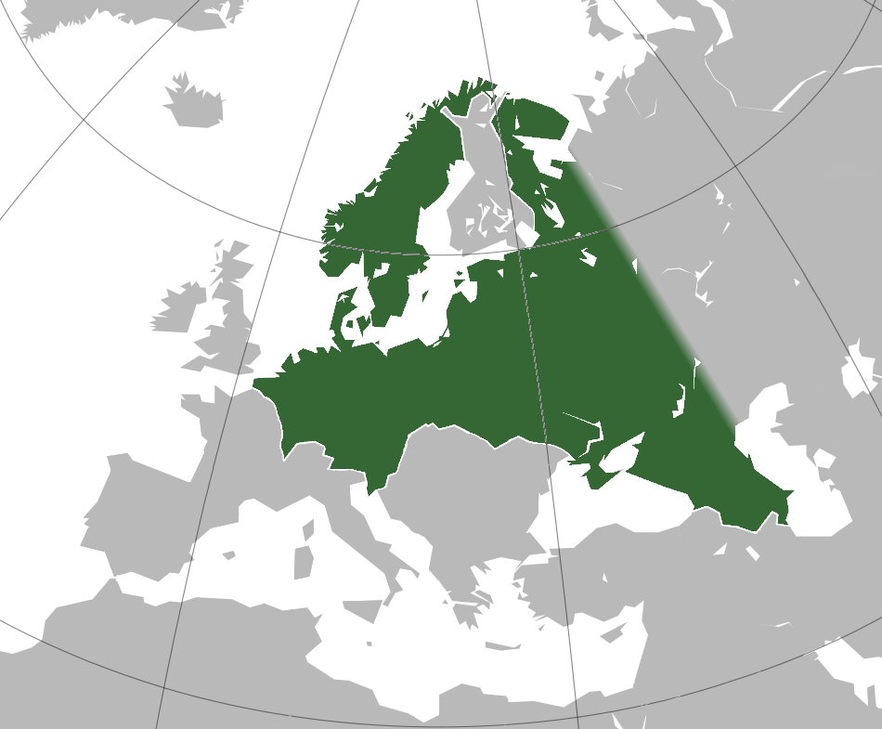

*Pictured: Planned approximate extent of the Greater German Reich after completion of Generalplan Ost. Source:* [*https://www.obersalzberg.de/en/exhibition/zweiter-weltkrieg/occupied-europe/utopie-grossgermanisches-reich/*](https://www.obersalzberg.de/en/exhibition/zweiter-weltkrieg/occupied-europe/utopie-grossgermanisches-reich/)

The Nazi Party was an extreme right wing political party based on racial hierarchy, anti-communism, and German irredentism.[1] A little party during the relatively prosperous 1920s, the Great Depression caused an outstanding increase in support for the Nazi Party by the 1933 election. In that election, the Nazi Party had won 44% of the vote, helped by political violence, but with sincere support from about 1/3rd of the electorate. The political violence of Nazis was organized, partly, by **Heinrich Himmler.** And the sincere supporters were made of men like **Hans Ehlich** and **Konrad Meyer-Hetling.**

Heinrich Himmler was a member of the Nazi party starting from 1923, and of the paramilitary arm, the SS, of the Nazi party from 1925 onward. Appointed leader of the SS in 1929, he led the organization competently, according to the goals of the Nazi party. His interest in racially pure German expansion, led to the recruitment of like-minded Germans into the organization.

Hans Ehlich was a doctor who was inclined to right-wing movements starting in 1923, even supporting Hitler’s attempted government overthrow, the Beer Hall Putsch. His education as a doctor led to his employment at the Nazi Race and Public Health office, overseeing subdepartments "Volkstumsarbeit" "Minorities" "Race and Public Health" "Immigration and resettlement" "Occupied Territories."

For Konrad Meyer, his education as an agricultural scientist and participation in party politics as an elected Nazi politician led to his high rank in the bureaucracy and membership of the SS. By World War 2, his education and agricultural understanding was essential to Nazi ideological goals led to position directly under Heinrich Himmler.

The geopolitical situation of Europe from 1933 to 1939 was defined by the politicking of national ideological movements, principally Nazi Germany.[2] Nazi Germany attempted to reclaim national honor by violating the provisions of the Versailles Treaty as it fit Nazi ideological goals: remilitarization, national expansion, genocide of Slavs, jews, communists, and other selected groups. It was done successfully by the unification of German-speaking territories and reassertion of the German sovereignty over the Rhineland in preparation for what would become World War 2. Partway through World War 2, immediately before the invasion of the Soviet Union in Operation Barbarossa, Heinrich Himmler commissioned Generalplan Ost, the plan for the deportation and extermination of Eastern Europeans, then the resettlement of Eastern Europe.

The work was done by Hans Ehlich and Konrad Meyer.

The plan grew in scale as the war advanced. It initially called for the partial deportation of Poles to be replaced with Germans. By the peak of German expansion in 1942, before the defeat at Stalingrad, the plan called for the deportation 100+ million of Eastern Europeans across the Ural Mountains and 10s of millions of their deaths, either by intentional extermination or neglect.[3]

But the plan never got to this scale. The small-scale (in comparison) deportations were ordered by Heinrich Himmler then organized by Hans Ehlich and Konrad Meyer, separately.

Ehlich had already participated in the Einsatzgruppen killings in the General Government of occupied Poland, and he organized the deportation of 40,000 people into the General Government of Nazi-occupied Poland.[4] Meanwhile, Konrad Meyer implemented the small-scale colonization of the Polish-free territory, with a few thousand German settlers.

These partial implementations had to be stopped because of the reversal of fortunes in the eastern front by 1944. The war ended in 1945. Heinrich Himmler committed suicide on May 23, 1945. Konrad Meyer served about 2 years in an internment camp then worked as an agricultural professor until his death in April 25, 1973. Hans Ehlich served 1 year and 9 months in an internment camp, then worked as a doctor until retirement. He died March 30, 1991.

The first publication of Generalplan Ost can be found at the Internet Archive in scanned format, available for download.

**Permalink to Generalplan Ost Source:**  <https://archive.org/details/GeneralplanOst/mode/2up>

**Annotated Bibliography in Chronological Order**

Ihor Kamenetsky, *Secret Nazi Plans for Eastern Europe: A Study of Lebensraum Policies*

*Internet Archive*. (1961b). Internet Archive. <https://archive.org/details/SecretNaziPlansForEasternEuropeAStudyOfLebensraumPolicies_201609>

Ihor Kamenetsky was born in the Soviet Union in 1927. He became a refugee from the Soviet Union during World War 2, eventually going to the United States on a scholarship in 1949. He became a historian. His works are based exclusively in those subjects. This Generalplan Ost book defines the plan of Nazi Germany as ideological then explores the enforcement of the plan in escalating stages. Incorporation of acceptable peoples, then enslavement of useful but defined inferior peoples, then extermination of defined inferior. This was influential in establishing the standard view of the plan with almost all further studies influenced by the view of this book or the next.

Gumkowski, Janusz., and Leszczyński, Kazimierz. *Poland under Nazi Occupation*. Warsaw: Polonia Pub. House, 1961.

Janusz and Kazimierz were Polish historians born in 1905 and 1913, respectively. Their historical works are about World War 2, specifically Polish experiences during World War 2, probably influenced by their nationality. This work is notably for being the first complete reference to Generalplan Ost as “Generalplan Ost.” They frequently collaborated together. This book set the standard interpretation for what Generalplan Ost is. A plan for the extermination of Eastern European peoples that was formalized by Heinrich Himmler. This type of plan was theorized by Nuremburg trailers but confirmed by these two researchers.

*General Plan East Article*. (n.d.-b). General Plan East Hitler's Master Plan for Expansion Czeslaw Madajczyk *Polish Western Affairs* 1962, vol. iii no 2 <http://www.worldfuturefund.org/wffmaster/Reading/GPO/gpoarticle.HTM>

Excerpt from cited book. Madajczvk was a Polish historian and Communist, affiliated with the Socialist Party, then Polish Workers Party. His work on Generalplan Ost is considered seminal by both German and Polish historians. It’s a reference for specific numbers of planned deportation and the incomplete knowledge because of probably destroyed Generalplan Ost documents.

Madajczyk, Czeslaw. *Vom Generalplan Ost Zum Generalsiedlungsplan. 1994. De Gruyter Saur.*Same historian. From Generalplan Ost to the general settlement plan as this title is translated. Taken front the UCSB library. Useful for reference in comparison to more modern works but this book is too soon after the fall of the Soviet Union to have complete archival reference from them.

Lower, Wendy. “A New Ordering of Space and Race: Nazi Colonial Dreams in Zhytomyr, Ukraine, 1941-1944.” *German Studies Review* 25, no. 2 (2002): 227–54. <https://doi.org/10.2307/1432991>.

This is a history of Nazi policy in Ukraine and Poland as it relates to settlement and deportation, with an emphasis on failures and dissent by subordinates and collaborators.

Furber, David. “Near as Far in the Colonies: The Nazi Occupation of Poland.” *The International History Review* 26, no. 3 (2004): 541–79. <http://www.jstor.org/stable/40110519>.

This history is speicifically on Poland as a colonization project by Nazi Germany. The Germanization of Poland by settlement, mixing, expulsion, and genocide. Explicit comparison is made between the attempted colonization of Poland with colonization of Africa and Asia.

Buttar, Prit. *Between Giants: The Battle for the Baltics in World War 2*, 2013.  
  
Prit Buttar is a living historian and doctor. Personal interest in World War 2 began after meeting an 83 year old nurse who was recounting fleeing the Soviet Union. Born well after World War 2, his writing is not affected by personal experience. He is multilingual, meaning for his studies, he is able to translate German archives himself. Most of his works are non-fiction history books, but two are novels. This book is specific focus on the Baltic states and their history during the Holocaust.

Giaccaria, Minca, Paolo, Claudio, ed. (2016). *Hitler’s Geographies: The Spatialities of the Third Reich.* Chicago, USA: The University of Chicago Press.

Most recent work referenced. Paolo’s only publication is, as far as I can tell, just *Hitler’s Geographies*. His co-author, Claudio, is a geography professor mostly dealing with space, politics, and the interaction between them. Their work can be compared with Czeslaw, because of the use of data, but with enough time that the archival information of the USSR has been sifted through and analyzed. It is a modernized data reference for the scale of the plan with the focus on the political use of territory in geopolitics and settlement of Generalplan Ost.

1. Ihor Kamenetsky, *Secret Nazi Plans for Eastern Europe: A Study of Lebensraum Policies* *Internet Archive*. (1961b).
2. Gumkowski, Janusz., and Leszczyński, Kazimierz. *Poland under Nazi Occupation*. Warsaw: Polonia Pub. House, 1961. “In these genocidal plans, the questions of deportation, the extent of Germanization among the people woh *(sic)* were to be deported and the resettlement of Germanic peoples were dominant.”
3. Giaccaria, Minca, Paolo, Claudio, ed. (2016). *Hitler’s Geographies: The Spatialities of the Third Reich.* Chicago, USA: The University of Chicago Press.
4. Furber, David. “Near as Far in the Colonies: The Nazi Occupation of Poland.” *The International History Review* 26, no. 3 (2004): 541–79.